NUST COLLEGE OF
ELECTRICAL AND MECHANICAL ENGINEERING
Smart Stethoscope
A PROJECT REPORT
DE-43 (DC & SE)

Submitted by
NS Hira Irshad
NS Fatima
PC Areeba Shahid
ASC Bushra Naseer


BACHELORS
DE-43(DC&SE)
YEAR2025
IN
COMPUTER ENGINEERING
YEAR
2025
PROJECT SUPERVISOR
DR. USMAN AKRAM
DR. SHAHID ISMAIL
DEPARTMENT OF COMPUTER & SOFTWARE ENGINEERING
COLLEGE OF ELECTRICAL & MECHANICAL ENGINEERING
NATIONAL UNIVERSITY OF SCIENCES AND TECHNOLOGY,
ISLAMABAD, PAKISTAN

Certification
This is to certify that Hira Irshad, Fatima, Areeba Shahid, Bushra Naseer have successfully completed the final project Smart Stethoscope, at the College of Electrical & Mechanical Engineering, to fulfill the partial requirement of the degree Computer Engineering.
Signature of Project Supervisor
Dr. Usman Akram
Professor

Sustainable Development Goals (SDGs)
SDG No | Description of SDG | SDG No | Description of SDG
SDG 1 | No Poverty | SDG 9 | Industry, Innovation, and  Infrastructure
SDG 2 | Zero Hunger | SDG 10 | Reduced Inequalities
SDG 3 | Good Health and Well Being | SDG 11 | Sustainable Cities and Communities
SDG 4 | Quality Education | SDG 12 | Responsible Consumption and Production
SDG 5 | Gender Equality | SDG 13 | Climate Change
SDG 6 | Clean Water and Sanitation | SDG 14 | Life Below Water
SDG 7 | Affordable and Clean Energy | SDG 15 | Life on Land
SDG 8 | Decent Work and Economic  Growth | SDG 16 | Peace, Justice and Strong In-  stitutions
 |  | SDG 17 | Partnerships for the Goals


Sustainable Development Goals

Complex Engineering Problem
Range of Complex Problem Solving
 | Attribute | Complex Problem
1 | Range of conflicting requirements | Involve wide-ranging or conflicting technical, engineering and other issues. | ✓
2 | Depth of analysis re-  quired | Have no obvious solution and require abstract thinking, originality in analysis to formulate suitable models. | ✓
3 | Depth of knowledge re-  quired | Requires research-based knowledge much of which is at, or informed by, the forefront of the professional discipline and which allows a fundamentals-based, first principles analytical approach. | ✓
4 | Familiarity of issues | Involve infrequently encountered issues | ✓
5 | Extent of applicable codes | Are outside problems encompassed by standards and codes of practice for professional engineering. | ✓
6 | Extent of stakeholder involvement and level of  conflicting requirements | Involve diverse groups of stakeholders with widely varying needs. | ✓
7 | Consequences | Have significant consequences in a range of contexts. | ✓
8 | Interdependence | Are high level problems including many component parts or sub-problems | ✓
Range of Complex Problem Activities
 | Attribute | Complex Activities
1 | Range of resources | Involve the use of diverse resources (and for this purpose, resources include people, money, equipment, materials, information and technologies). | ✓
2 | Level of interaction | Require resolution of significant problems arising from interactions between wide ranging and conflicting technical, engineering or other issues. | ✓
3 | Innovation | Involve creative use of engineering principles and research-based knowledge in novel ways. | ✓
4 | Consequences to society and the environment | Have significant consequences in a range of contexts, characterized by difficulty of prediction and mitigation. | ✓
5 | Familiarity | Can extend beyond previous experiences by applying principles-based approaches. | ✓

Dedicated to our family, teachers and friends who helped shape us into who we are today

Acknowledgment
We would like to heartily offer our thanks to our supervisors, Dr. Usman Akram, Dr. Shahid Ismail and Dr. Sajid Gul Khawaja, who helped us a lot, tremendously, on each and every single issue, whose help and guidance became a source of strong determination for us. Thank You Sirs, you played a great role in our lives, one that we can never forget.

Abstract
Cardiovascular diseases remain leading causes of mortality worldwide, particularly in low-resource settings where access to advanced diagnostic tools is limited. Traditional stethoscopes rely heavily on the clinician’s expertise and offer limited potential for digital storage, analysis, or telemedicine applications. To address these challenges, this work presents the design and development of a Smart Stethoscope that integrates embedded electronics, signal processing, and machine learning to enable accurate, real-time auscultation and classification of heart sounds.
The proposed system comprises a hardware device integrated with traditional stethoscope for the recording and transmission of heart sounds to a mobile application. Captured auscultatory signals are processed to denoise, which are subsequently classified using deep learning models deployed on a mobile application. This enables offline analysis and prediction of pathological conditions such as murmurs and valve diseases.
By combining traditional auscultation with modern AI-based analytics, the proposed smart stethoscope serves as a low-cost, portable, and intelligent diagnostic tool aimed at early detection of cardiovascular disorders, especially in rural or resource-constrained environments. This work thus contributes to the advancement of point-of-care diagnostics and supports the broader vision of accessible, AI-enabled healthcare.

Keywords: Smart Stethoscope, Heart Sound Classification, Embedded System, ESP32, Machine Learning, Deep Learning, Spectrogram, Telemedicine, Portable Diagnostic Device, PCG Signal Processing, Offline Medical Analysis, AI in Healthcare, Edge Computing

Contents
Certification i
Sustainable Development Goals (SDGs) ii
Complex Engineering Problem iii
Acknowledgment v
Abstract vi
List of Figures xii
List of Tables xiv
Chapter 1: Introduction 1
1.1 Domain of the Project 1
1.2 Scope of the Project 1
1.3 Motivation 2
1.4 Problem Statement 2
1.5 Aims and Objectives 2
1.6 Expected Outcomes 3
1.7 Report Organization 3
Chapter 2: Background and Related Work 5
2.1 Overview of Heart Sounds and Related Cardiovascular Conditions 5
2.2 Related Work 6
2.2.1 Development of electronic stethoscopes: 6
2.2.2 Denoising of PCG signals: 8
2.2.3 Classification of PCG signals using artificial intelligence: 9
2.4 Conclusion 10
Chapter 3: Project Design 11
3.1 Overview 11
3.2 System Architecture 11
3.3 Hardware Design 11
3.4 Software Design 12
3.5 AI Model Integration 12
3.6 Summary 13
Chapter 4: Hardware Design of the Smart Stethoscope 14
4.1 Microphone: 14
4.2 Microcontroller Unit (MCU) 14
4.2.1 Microphone Interface and Signal Acquisition 15
4.2.2 Audio Data Handling and WAV File Generation 15
4.2.3 Wi-Fi Access Point Mode and Web Server Functionality 16
4.2.4 File Management and Storage Integrity 16
4.2.5 System Timing and Performance Monitoring 17
4.3 Power Supply and Battery Management 17
4.3.1 Lithium-Ion Battery (3.7V 2000mAh 18650 Cell) 17
4.3.2 TP4056 Lithium-Ion Charging Module 18
4.3.3 MT3608 DC-DC Boost Converter 18
4.4 Enclosure Design and 3D-Printed Chamber 18
4.4.1 Design Considerations 18
4.5 Complete Hardware Setup 19
4.6 Summary 20
Chapter 5: Denoising of Heart Sounds 21
5.1 Introduction 21
5.2 Butterworth Bandpass Filtering 21
5.3 Variational Mode Decomposition (VMD) 21
5.4 Implementation and Results 22
5.5 Advantages of the Hybrid Approach 23
5.6 Summary 23
Chapter 6: Quality Assessment of PCG signals 24
6.1 Introduction 24
6.2 Methodology Overview 24
6.3 Spectral Analysis of Heart Sounds 24
6.4 Reference Spectrum and Similarity Measure 25
6.5 Threshold-Based Classification 25
6.6 Results and Observations 25
6.7 Advantages and Limitations 26
6.8 Conclusion 27
Chapter 7: Classification Using Deep Learning 28
7.1 Introduction 28
7.2 Dataset Description 28
7.2.1 Introduction 28
7.2.2 CIRCOR DigiScope Dataset 28
7.2.3. Yaseen Dataset 29
7.2.4. Unified Use for Binary and Multi-class Classification 29
7.2.5. Conclusion 30
7.3. Signal Processing and Denoising of Phonocardiogram (PCG) Signals 30
7.3.1 Introduction 30
7.3.2 Preprocessing and Denoising Pipeline 30
7.3.3 Conclusion 33
7.4 Feature Extraction from PCG Signals 34
7.4.1 Introduction 34
7.4.2 Extracted Features 34
7.4.3 Yaseen Dataset Features: 37
7.4.4 Implementation Note 37
7.4.5 Conclusion 38
7.5 Deep Learning Models for PCG Signal Classification 38
7.5.1 Introduction 38
7.5.2 Model-1: 2D CNN on Spectrograms of Denoised PCG Signals 38
7.5.3 Model-2: MLP on Extracted Features from Denoised Signals 40
7.5.4 Model-3: Ensemble of CNN and MLP with Gradient Boosting 42
7.5.5 Model-4: Lightweight CNN + Gradient Boosting (Mobile Friendly) 44
7.5.6 Model-5: Fully Convolutional Two-Stage CNN 46
7.5.7 Model-6: Multi-Class 1D CNN on MFCC + Wavelet Features (Yaseen Dataset) 47
7.5.8 Model-7: Multi-Class 1D CNN on Structured Features 49
7.5.9 Summary Table 50
7.5.10 Conclusion 51
Chapter 8: Transfer Learning 52
8.1 Introduction 52
8.2 Methodology 52
8.3 Dataset Description 53
8.3.1 Signal Characteristics 53
8.3.2 Class Distribution and Labeling Approach 53
8.3.3 Data Challenges 54
8.4 Technical Pipeline 54
8.4.1 Preprocessing 54
8.4.2 Spectrogram Generation and Class Organization 55
8.4.3 Experimental Design: Two Approaches 55
8.5. Transfer Learning with Deep Learning Architectures 56
8.5.1 Why Transfer Learning? 56
8.5.2 Model Implementation 56
8.6 Experimental Results and Analysis 57
8.6.1 Transfer Learning with Unfiltered PCG Signals 57
8.6.2 Transfer Learning with Filtered PCG Signal 59
8.6.3. Evaluation and Comparative Justification 61
8.6.4 Summary of Findings 62
8.7 Conclusion: 62
Chapter 9: Smart Stethoscope Mobile Application 63
9.1 How to Use the Smart Stethoscope 63
Chapter 10: Conclusion and Future Work 69
10.1 Conclusion 69
10.2 Future Work 69
References 71

List of Figures
Figure 1.1: System-level Diagram
Figure 2.1: PCG recording of a heart sound
Figure 2.2: PCG Signals of the (a) Normal, and CVD diseases (b) Aortic Stenosis (c) Aortic Regurgigation (d) Mitral Stenosis and (e) Mitral Regurgigation
Figure 3.1: System Architecture
Figure 4.1: ESP32’s Asynchronous Server Webpage
Figure 5.1: Original and denoised PCG signal acguired from smart stethoscope device
Figure 5.2: Original and denoised PCG signal acguired from smart stethoscope device
Figure 6.1: Average FFT magnitude spectrum of clean signals obtained from CirCor DigiScope Phonocardigram Dataset
Figure 6.2: Results of quality assessment of recorded PCG signals alongwith their waveforms and FFT (a) Noisy and (b) Clean
Figure 7.1: Original and EMD reconstructed signal plots
Figure 7.2: Original and NLMS reconstructed signal plots
Figure 7.3: Spectrogram based custom CNN binary model architecture
Figure 7.4: Confusion matrix of spectrogram based custom CNN binary model
Figure 7.5: Features based custom MLP binary model architecture
Figure 7.6: Confusion matrix of features based custom MLP binary model
Figure 7.7: Architecture of Gradient Boosting–Ensembled Binary Classification Model
Figure 7.8: Confusion matrix of Gradient Boosting–Ensembled Binary Classification Model
Figure 7.9: Spectrogram based custom CNN model architecture
Figure 7.10: Confusion matrix of spectrogram based custom CNN model architecture
Figure 7.11: Dual-stage spectrogram-based CNN architecture
Figure 7.12: Confusion matrix of Dual-stage spectrogram-based CNN
Figure 7.13: Feature based custom CNN binary model architecture
Figure 7.14: Confusion matrix of feature based custom CNN binary model
Figure 7.15: Feature based custom CNN multi-class model architecture
Figure 7.16: Confusion matrix of feature based custom CNN multi-class model
Figure 8.1: Spectrogram of a PCG signal from CirCor DigiScope Phonocardiogram Dataset
Figure 8.2: Confusion Matrix of transfer learning using AlexNet on signals from CirCor DigiScope Phonocardiogram dataset
Figure 8.3: Confusion Matrix of transfer learning using MobileNet on signals from CirCor DigiScope Phonocardiogram dataset
Figure 8.4: Confusion Matrix of transfer learning using GoogleNet on signals from CirCor DigiScope Phonocardiogram dataset
Figure 8.5: Confusion Matrix of transfer learning using AlexNet on pre-processed signals from CirCor DigiScope Phonocardiogram dataset
Figure 8.6: Confusion Matrix of transfer learning using MobileNet on pre-processed signals from CirCor DigiScope Phonocardiogram dataset
Figure 8.7: Confusion Matrix of transfer learning using GoogleNet on pre-processed signals from CirCor DigiScope Phonocardiogram dataset
Figure 9.1: Navigation to Help upon starting Smart Stethoscope Mobile App
Figure 9.2: Connect Device page of Smart Stethoscope Mobile App
Figure 9.3: Connect Device page of Smart Stethoscope Mobile App
Figure 9.4: Diagnosis result and waveform of a real-time PCG signal recording on Smart Stethoscope Mobile App
Figure 9.5: Saved recordings page of Smart Stethoscope Mobile App

List of Tables
Table 4.1: Complete hardware setup
Table 7.1: Definitions and interpretations of spectral features extracted from PCG signals
Table 7.2: Description of temporal and statistical features extracted from PCG signals
Table 7.3: Summary of Classification models
Table 8.1: Result of transfer learning using GoogleNet, AlexNet and MobileNet on original signals from CirCor DigiScope Phonocardiogram Dataset
Table 8.2: Result of transfer learning using GoogleNet, AlexNet and MobileNet on pre-processed signals from CirCor DigiScope Phonocardiogram Dataset
Table 8.3: Summary of results and observations from transfer learning on CirCor DigiScope Phonocardiogram dataset

Chapter 1: Introduction

1.1 Domain of the Project
This project falls under the interdisciplinary domain of biomedical engineering, embedded systems and artificial intelligence (AI). It particularly emphasizes the integration of low-power embedded hardware, digital signal processing and deep learning techniques for non-invasive cardiac auscultation.
This project focuses on digitizing and automating the diagnosis of heart conditions using a smart stethoscope that is capable of acquiring heart sounds, denoising, assessing quality and analyzing them using trained machine learning models and providing diagnostic support to clinicians and healthcare workers. This project is particularly relevant in the context of telemedicine and remote healthcare domains that are witnessing rapid growth due to the rising demand for accessible and affordable medical services. In many rural and resource-constrained areas, the availability of trained cardiologists and diagnostic tools is limited. The smart stethoscope aims to bridge this gap by empowering primary healthcare workers with a tool that assists in early detection of heart diseases, thus enabling timely referral and treatment.

1.2 Scope of the Project
This project focuses on the end-to-end design, development, and evaluation of a portable, low-cost smart stethoscope system intended for the early detection and classification of cardiovascular conditions.
The system will acquire phonocardiogram (PCG) signals using a high-sensitivity electret microphone integrated into a stethoscope chest piece. The acquired heart sounds are digitized and passed to a mobile device for denoising, quality assessment and classification. Classification is performed using trained deep learning models that are optimized for deployment on mobile hardware. These models are capable of not only distinguishing between normal and abnormal heart sounds but also identifying specific valvular heart diseases such as aortic stenosis or mitral regurgitation. The models are trained on publicly available datasets and validated for accuracy, sensitivity, and specificity.
A key feature of the proposed system is its offline operation capability. All processing and classification tasks are performed directly on the mobile device without requiring continuous access to cloud services or internet connectivity. This design choice enhances portability, reliability, and accessibility especially in resource-limited or rural healthcare settings where internet access may be intermittent or unavailable.
In addition to the electronic and software components, the project also covers the design and fabrication of the device enclosure. A 3D-printed housing is developed to securely mount all internal components including the microphone, microcontroller, battery, and charging modules. The design prioritizes ergonomics and ease of use in clinical environments.

1.3 Motivation
Traditional stethoscopes are subjective and dependent on the experience and skill of the physician. Misinterpretation or delayed diagnosis due to subtle heart anomalies can lead to serious health complications. In rural and remote areas, the unavailability of trained professionals further escalates this issue. The motivation behind this project arises from the need to bridge this diagnostic gap using a smart, affordable, and user-friendly alternative that empowers frontline health workers and supports clinical decision-making. With advancements in embedded AI, it is now feasible to bring computationally intelligent systems into handheld diagnostic devices that are both reliable and accessible. Also the existing smart stethoscopes require internet connectivity as their classification models are deployed on cloud which becomes a constraint for areas with weak or no internet connectivity. This project overcomes this limitation as it utilizes edge computing.

1.4 Problem Statement
Conventional auscultation methods suffer from high subjectivity and reliance on expert interpretation. Furthermore existing digital stethoscope solutions are often expensive or require continuous internet access for cloud-based AI inference. There exists a significant need for a compact, battery-powered, AI-assisted stethoscope that performs real-time analysis of physiological sounds and works effectively in offline and resource-limited environments.

1.5 Aims and Objectives
The primary aim of this project is to develop a smart stethoscope capable of real-time classification of cardiopulmonary sounds using deep learning models operating entirely on a mobile platform. The specific objectives include:
- To design a stethoscope system using a high-sensitivity microphone module and microcontroller.
- To develop deep learning models for binary and multi-class classification of heart sounds.
- To develop mobile application logic for signal acquisition, noise reduction, quality assessment and offline inference using deep learning models.
- To validate the system with real-world PCG recordings and evaluate classification accuracy, battery performance, and usability.

1.6 Expected Outcomes
Upon completion, the project is expected to yield a fully functional prototype of a smart stethoscope capable of:
- Accurately recording and classifying heart sounds into normal or abnormal categories.
- Operating efficiently in offline mode without dependence on cloud services.
- Providing consistent and objective diagnostic support to medical professionals and health workers.
- Serving as a foundation for further research into multi-condition classification, telehealth integration, and real-time monitoring.
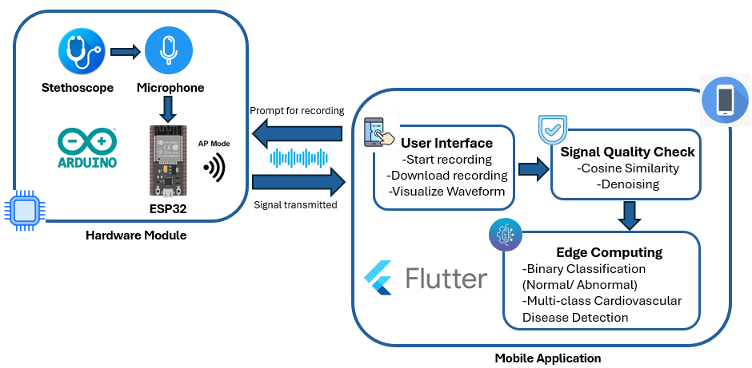
Figure 1.1: System-level Diagram

1.7 Report Organization
The organization of the thesis is as follows:
• Chapter 2 gives a literature review of what others have done to solve the same issue.
• Chapter 3 gives an overview of our project, its function and architecture.
• Chapter 4 discusses the technical details of hardware.
• Chapter 5 discusses the denoising of pcg signals acquired from smart stethoscope device.
• Chapter 6 discusses the quality assessment of pcg signals acquired from smart stethoscope device.
• Chapter 7 discusses the deep learning models used for classification.
• Chapter 8 discusses the functionality of the mobile application.
• Chapter 9 gives a conclusion, and plans for future development

Chapter 2: Background and Related Work

2.1 Overview of Heart Sounds and Related Cardiovascular Conditions
Heart sounds are the acoustic manifestations of mechanical activity within the cardiac cycle primarily resulting from the closure of heart valves and the turbulent flow of blood through the chambers and vessels of the heart. These sounds can be auscultated non-invasively through the chest wall using a stethoscope and provide crucial information about the functional status of the cardiovascular system. The normal heart sounds, denoted as S1 and S2 correspond to the closure of the atrioventricular and semilunar valves respectively. These are typically followed by short silent periods that represent different phases of the cardiac cycle. In certain physiological or pathological conditions, additional sounds such as S3, S4 or murmurs may be heard, each providing diagnostic clues about underlying cardiac anomalies.
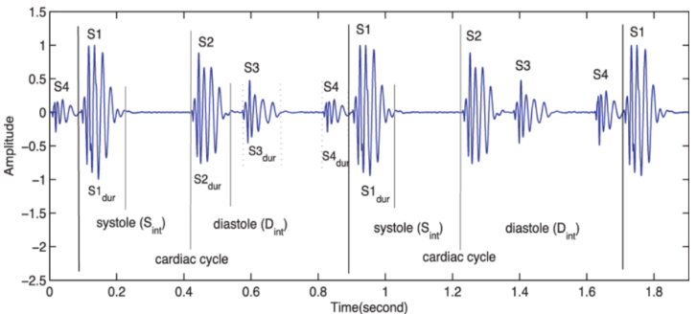
Figure 2.1: PCG recording of a heart sound

The acoustic characteristics of heart sounds such as intensity, frequency, duration, and timing carry valuable diagnostic information. For instance, a soft or diminished S1 may indicate mitral regurgitation while a loud or split S2 can be associated with pulmonary hypertension or atrial septal defect. Heart murmurs which are turbulent flow sounds heard between the main heart sounds often signal structural abnormalities like valvular stenosis, valvular regurgitation or septal defects. The proper interpretation of these sounds enables clinicians to detect a wide range of cardiac conditions including congenital heart disease, valvular heart disease, cardiomyopathy and heart failure.
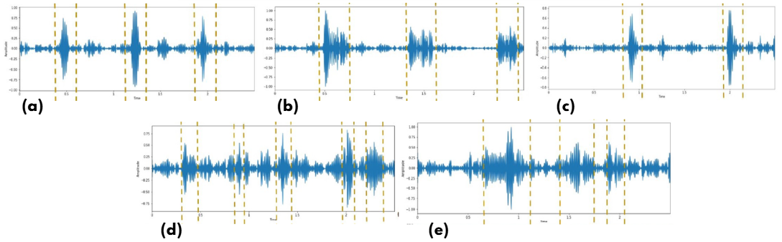
Figure 2.2: PCG Signals of the (a) Normal, and CVD diseases (b) Aortic Stenosis (c) Aortic Regurgigation (d) Mitral Stenosis and (e) Mitral Regurgigation
Early diagnosis is critical for the management and prevention of CVD-related complications. Auscultation being a simple, cost-effective, and non-invasive diagnostic method continues to play a significant role in early-stage cardiovascular screening particularly in primary and rural healthcare settings where access to advanced imaging and laboratory facilities may be limited. Despite its diagnostic value, traditional auscultation is heavily reliant on the experience, hearing ability, and interpretative skill of the physician which introduces subjectivity and variability in clinical assessments. Moreover subtle pathological sounds may be easily missed in noisy environments or by less-experienced clinicians. This has created a need for automated and objective methods for capturing, analyzing, and interpreting heart sounds, thereby reducing diagnostic errors and improving patient outcomes.

2.2 Related Work
The integration of intelligent systems in stethoscope design has gained significant attention in recent years, driven by the increasing need for early diagnosis, remote healthcare delivery, and objective auscultation methods. This chapter provides a comprehensive review of existing work related to smart stethoscopes, heart sound denoising and classification and deep learning applications in auscultation.

2.2.1 Development of electronic stethoscopes:
The stethoscope being a fundamental tool in medical diagnostics has undergone significant evolution with the advancement of electronic technology. Traditional stethoscopes are often limited due to the variability in auscultation results that depend on the clinician’s hearing ability and their inability to record sounds for further analysis. These limitations have driven the development of electronic stethoscopes which aim to overcome such challenges by incorporating sound amplification, digital processing and enhanced analytical capabilities. Numerous practical implementations have demonstrated the feasibility and advantages of electronic auscultation systems.
Lo et al. (2016) [1] proposed a cost effective Bluetooth enabled wearable digital stethoscope for murmur detection indicating a shift towards mobile and user friendly diagnostic devices. Wang et al. (2017) [2] introduced a heart sound acquisition and analysis system based on PSoC4 which showcased the application of programmable systems on a chip for biomedical purposes. Talukdar et al. (2018) [3] developed a battery-powered electronic stethoscope that uses a microcontroller to amplify and record heart sounds highlighting the practicality of compact devices for heart sound analysis. The integration of wireless technology such as Bluetooth has further enabled remote monitoring and seamless data transmission.
Hadiyoso et al. (2020) [4] developed an electronic stethoscope system using a condenser microphone, pre-amplifier, bandpass filter, and audio amplifier integrated with mobile technology to facilitate online data transmission to the cloud for remote health monitoring. Joshi et al. (2021) [5] also created a Bluetooth based wireless digital stethoscope to overcome the limitations of conventional devices by enabling wireless auscultation. Wu et al. (2021) [6] utilized Raspberry Pi to build an electronic stethoscope equipped with Bluetooth capabilities that support recording, storing, and transmitting cardiopulmonary sounds.
Recent research has concentrated on enhancing the accuracy and reliability of electronic stethoscopes by applying advanced signal processing techniques. Wu et al. (2022) [7] presented an electronic stethoscope that incorporates a condenser microphone embedded in the chest piece to capture cardiopulmonary sounds and integrates amplification and filtering circuits along with Fast Fourier Transform (FFT) analysis to evaluate noise reduction performance. Various microphone placements were tested with results indicating that placing the microphone in cork-insulated housing within the stethoscope head offers the best noise reduction.
Li et al. (2023) [8] contributed to this field by researching electronic stethoscope systems and signal processing algorithms and explored the progression of these devices with a focus on sensor technologies including contact and air-coupled sensors as well as digital signal processing algorithms like noise reduction heart sound segmentation and feature extraction and recognition which enhance the diagnostic capability of heart sound analysis. Potdar (2024) [9] designed and implemented a high-fidelity electronic stethoscope using components such as a low-pass Butterworth filter, compensatory circuit, graphical LCD, and an AVR Atmega-32 microcontroller where the device amplifies heart sounds electronically, digitizes them and transmits them wirelessly for remote monitoring and real-time visual analysis. Fahim et al. (2024) [10] developed a wireless phonocardiograph system that integrates Bluetooth-enabled hardware with smartphone and web applications for remote recording and analysis of heart sounds, offering a cost-effective and portable PCG acquisition solution by combining a traditional stethoscope chest piece with a high sensitivity microphone to enable real-time listening, visualization, recording, and storage of heart sounds on digital platforms.

2.2.2 Denoising of PCG signals:
White noise and other sounds produced in the recording surroundings, such as human speech, are among the several types of noises that are typically present in recorded heart sounds. Noise can significantly hinder the accuracy of heart sound segmentation and classification, prompting numerous studies to explore effective denoising techniques aimed at improving overall performance in these tasks. Several approaches have involved the use of signal filters to remove unwanted noise from heart sounds during the preprocessing stage prior to classification, as demonstrated in studies [11], [12] and [13]. High-pass filters have been specifically employed to eliminate low-frequency noise, as seen in works [14] and [15]. However, bandpass filters have gained wider acceptance for heart sound denoising due to their ability to suppress both low- and high-frequency noise components as reported in studies [16] through [18]. A substantial number of research efforts have successfully implemented Butterworth bandpass filters [19] and [20] to [26] owing to their smooth frequency response and efficiency in preserving the core components of heart sounds. These filters are typically designed with a low cutoff frequency to eliminate extremely low-frequency noise and a high cutoff frequency to remove higher frequency disturbances, thereby ensuring a cleaner signal for subsequent processing and analysis.
Several Butterworth bandpass filters with varying cutoff frequency settings and orders have been used. For example, in [27], the cutoff frequency for a 4-th order Butterworth filter was set at 25-400 Hz, while in [28] and [29], the cutoff frequencies for a 5-th order Butterworth filter were 25-500 Hz and 25-250 Hz, respectively. Additionally, a number of additional filters, including the Chebyshev low-pass filter [30], [31], Savitzky–Golay filter [32], [33], and [34] Notch filter. In [35], spectrograms were merely chosen using a threshold of -30, -45, -60, or -75 dB to eliminate noise. Finding an appropriate threshold among the various heart sounds takes time, though. To quantify the noise and eliminate it from cardiac sounds, spectral subtraction [36], a more adaptable technique, was employed. The use of noise-free heart sound segments has been thought to be beneficial for heart sound analysis in addition to eliminating noise from heart sounds. Since clean heart sounds have a comparatively greater wavelet entropy than noisy heart sounds, wavelet entropy was employed as a characteristic to assess noise in heart sound segments [37].
In a different investigation, heart sounds, murmurs, low-frequency artifacts, and high-frequency noises were all separated using the empirical wavelet transform [38].

2.2.3 Classification of PCG signals using artificial intelligence:
Several studies have investigated the application of deep learning techniques for automatically detecting and classifying heart sounds demonstrating the growing interest in intelligent diagnostic systems. Yaseen et al. (2018) [39] proposed a hybrid framework for detecting cardiac disorders that utilized Mel Frequency Cepstral Coefficients (MFCCs) and Discrete Wavelet Transform (DWT) features extracted from phonocardiogram (PCG) signals. The study evaluated multiple machine learning classifiers including Support Vector Machine (SVM), Deep Neural Networks (DNN), and Centroid Displacement-based k-Nearest Neighbor (KNN) for classification. Tang et al. (2018) [40] made a significant contribution by employing multi-domain feature extraction in combination with an SVM classifier using the PhysioNet/CinC Challenge 2016 dataset to extract a comprehensive set of 515 features from nine different domains such as time intervals, frequency spectrum of states, state amplitude, energy, record-level spectral content, cepstrum, cyclostationarity, high-order statistics, and entropy. An SVM with a radial basis function kernel was trained on these features for both signal quality assessment and classification. Yang et al. (2019) [41] introduced a novel approach using an envelope extraction model with empirical mode decomposition (EMD) to analyze heart sounds aiming to enhance the diagnostic capability of PCG signals for early cardiovascular disease detection. They developed a method to accurately identify cardiac cycles and extract time-domain features which were then combined with frequency-domain and wavelet-domain features to form robust feature vectors, and an SVM classifier was employed to classify signals as normal or abnormal. Chakraborty et al. (2020) [42] contributed to automated PCG analysis by developing a deep learning-based classification framework that distinguished between normal and abnormal heart sounds while addressing challenges such as class imbalance through class weighting during training. They converted one-dimensional PCG signals into spectrograms to shift analysis into the visual domain enabling the use of deep convolutional neural networks (CNNs) for automatic feature extraction which was followed by quality and abnormality classification. Alqudah et al. (2019) [43] focused on classifying unsegmented heart sound recordings by extracting instantaneous frequency-based features and compared the performance of random forest and k-nearest neighbor classifiers, achieving an accuracy of 95% while emphasizing the difficulties of feature extraction and the potential of machine learning methods for accurate classification without the need for segmentation. Abbas et al. (2022) [44] proposed an advanced attention-based method called CVT-Trans that utilized a convolutional vision transformer for classifying PCG signals into five categories namely normal, aortic stenosis, mitral regurgitation, mitral stenosis, and mitral valve prolapse. They employed a continuous wavelet transform-based spectrogram strategy to convert one-dimensional signals into two-dimensional spectrograms, achieving exceptional results with 100% accuracy, 99% sensitivity, 99.5% specificity, and a 98% F1-score using 10-fold cross-validation, highlighting the efficiency and reliability of their approach for heart valve disorder diagnosis.

2.4 Conclusion
The reviewed literature underscores notable progress in the design and implementation of smart stethoscope systems with numerous studies examining advancements in hardware and signal processing such as the deployment of sensitive microphones, amplification circuits, filtering methods, and seamless integration with mobile and web-based technologies. Machine learning techniques including support vector machines, deep neural networks, and k-nearest neighbors have demonstrated strong performance in the automatic classification of heart sounds particularly when multidomain or fused features like Mel Frequency Cepstral Coefficients and Discrete Wavelet Transform are utilized. These advancements reflect a growing convergence of biomedical engineering, artificial intelligence, and telemedicine aimed at enhancing diagnostic accuracy, system portability, and the ability to conduct cardiac assessments remotely. The incorporation of real-time visual interfaces along with mobile and cloud-based platforms has significantly improved the functionality and accessibility of these systems. In summary, the literature provides a strong basis for the continued development of smart stethoscope technologies and highlights their potential to revolutionize routine cardiac care through scalable, automated, and objective diagnostic solutions.

Chapter 3: Project Design

3.1 Overview
The design of the Smart Stethoscope encompasses a multidisciplinary integration of biomedical sensing, embedded systems, signal processing, machine learning, and mobile communication technologies. The system is developed to perform digital auscultation, denoise heart sounds and apply deep learning models to classify cardiac conditions as normal or abnormal. The design emphasizes portability, low power consumption, ease of use, and offline inference capability using a mobile app.

3.2 System Architecture
The proposed system consists of the following key modules:
- Sensing Unit – MAX9814 microphone module for capturing body sounds (heart and lung).
- Processing Unit – ESP32 microcontroller for analog-to-digital conversion, buffering, and wireless transmission.
- Power Unit – TP4056 Li-Ion charging module and MT3608 boost converter powered by a 3.7V 2000mAh Li-Ion 18650 battery.
- Mobile Unit – Flutter-based Android app for denoising, model inference, waveform visualization, and classification.
- AI Inference Unit – CNN models for offline classification of PCG signals.

3.3 Hardware Design
The MAX9814 microphone module is selected for its automatic gain control (AGC), low noise preamplifier, and high sensitivity. It captures subtle heart sounds while suppressing ambient noise. The output is connected to the ADC pin of the ESP32 microcontroller, which samples it at 4000 Hz to maintain fidelity for heart sound frequency ranges (20–500 Hz).
The ESP32 performs analog-to-digital conversion, stores buffered samples in memory, and transmits them wirelessly via WiFi in Access Point mode. It provides sufficient processing speed and onboard ADC resolution for the task.
A 3.7V 2000mAh Li-Ion 18650 battery is used as the primary power source. The TP4056 charging module ensures safe charging via USB. The MT3608 boost converter steps up the voltage to 5V for the ESP32 and microphone module. The power circuit is compact and optimized for low power consumption to allow hours of field use on a single charge.
All components are housed in a 3D-printed ABS enclosure. ABS was selected for its higher temperature resistance, strength, and durability, making it suitable for field use and long-term wear. The design includes compartments for the battery, ESP32, microphone, and openings for the USB port and sound inlet.

3.4 Software Design
The firmware running on the ESP32 continuously reads data from the microphone at 4000 Hz and transmits it wirelessly. A simple HTTP server is used to export the WAV data to the mobile app.
The Flutter-based mobile application connects to the ESP32’s WiFi, downloads the recorded audio, and processes it offline using Kotlin and Chaquopy (Python integration). The following operations are performed:
- Denoising: Python-based denoising using variational mode decomposition.
- Feature extration: MFCC and Wavelet features are extracted from the signal.
- Inference: A CNN model classifies heart sound based on features into normal or abnormal. If heart sound is abnormal, then another CNN model further species the type of abnormality.
All operations are designed to function without internet access, making the app suitable for rural or low-connectivity areas.

3.5 AI Model Integration
The design incorporates two TFLite models:
- Binary CNN Model : Trained on MFCC and wavelet features to classify PCG signals as normal or abnormal.
- Multi-class CNN Model: Trained on MFCC and wavelet features to classify PCG signals into five classes: normal, aortic stenosis, mitral stenosis, aortic regurgigation and mitral regurgigation.
Both models are optimized for size and latency to run on mid-range smartphones without GPU acceleration.
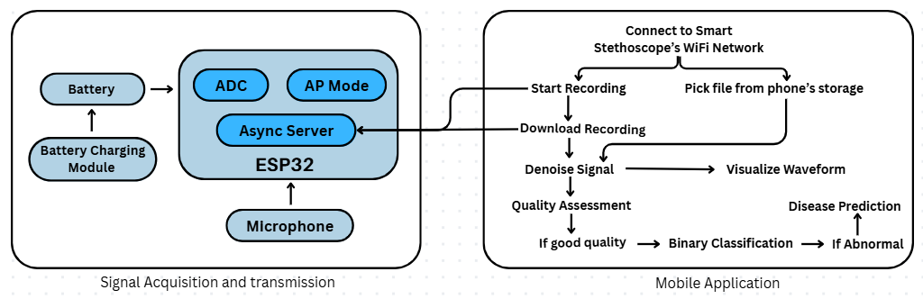
Figure 3.1: System Architecture

3.6 Summary
The system is designed to be a fully portable, smart auscultation tool that combines embedded sensing with edge-AI capabilities. The hardware is modular, compact, and low-power, while the software emphasizes offline capability, intelligent signal analysis and a user-friendly interface. This design is aimed at improving early detection of cardiac anomalies especially in primary and rural healthcare settings

Chapter 4: Hardware Design of the Smart Stethoscope

The hardware architecture of the smart stethoscope forms the backbone of the entire system enabling the acquisition and transmission of heart sounds for further analysis. The design incorporates a combination of traditional stethoscope functionality with modern embedded systems and communication technologies to ensure accurate auscultation and intelligent diagnostics.

4.1 Microphone:
The core component responsible for audio acquisition in the smart stethoscope system is the electret condenser microphone module specifically the MAX9814 microphone amplifier which is a high-performance integrated circuit designed for low-noise audio capture and includes automatic gain control that makes it particularly well-suited for recording heartbeats and lung sounds where the signal amplitude can vary significantly based on the placement of the sensor and the anatomical differences among patients as it supports a frequency response ranging from around 20 Hz to 20 kHz thereby covering the complete range of human hearing as well as the critical bandwidth necessary for capturing phonocardiogram and respiratory signals while providing an analog output that is directly connected to the analog input pin GPIO35 of the ESP32 microcontroller in the implemented system.

4.2 Microcontroller Unit (MCU)
At the core of the system lies the ESP32 microcontroller specifically the DOIT ESP32 DEVKIT V1 module chosen for its dual-core processing capability, built-in Wi-Fi and low power consumption making it ideal for portable medical applications. The ESP32 is configured to perform real-time audio recording from a microphone input, store the captured data as a WAV file in its internal flash memory using SPIFFS and provide an offline web interface for user interaction through Wi-Fi Access Point (AP) mode.
The ESP32 microcontroller is responsible for performing several critical functions which include sampling the incoming analog audio signals at a controlled sampling rate of 4000 Hz while also packetizing the captured audio data and transmitting it to a mobile device over Wi-Fi in addition to handling various user controls such as initiating or stopping the recording process downloading the recorded audio and displaying waveform visualizations and its capability to efficiently manage both Wi-Fi communication and analog-to-digital conversion operations simultaneously without introducing noticeable delays or performance issues is essential for supporting real-time healthcare monitoring in portable diagnostic systems.

4.2.1 Microphone Interface and Signal Acquisition
The Max9814 microphone module is directly connected to the ESP32 through the analog-to-digital converter pin GPIO35 which is specifically configured to operate with an 11-bit resolution rather than the standard 12-bit setting in order to reduce the amount of noise that may be introduced by fluctuations in the least significant bit and this configuration helps maintain a cleaner and more stable digital representation of the acquired heart sound signals.
During recording, the ESP32 samples the analog signal at a fixed rate of 4000 Hz, a value suitable for capturing phonocardiogram (PCG) signals, which typically lie within the 20 Hz to 500 Hz range. To ensure this sampling rate is maintained accurately, the code measures the elapsed microseconds between successive readings and inserts calibrated microsecond-scale delays (delay Microseconds) to compensate for variations caused by processing overhead.

4.2.2 Audio Data Handling and WAV File Generation
The ESP32 records audio samples for a fixed duration of 15 seconds, resulting in a total of 60,000 samples (4000 samples per second × 15 seconds).
To store the captured data:
- A standard WAV file header is dynamically generated in compliance with PCM audio format specifications (44 bytes total).
- The sampled audio values, initially 11 bits, are stored as 16-bit signed integers to maintain compatibility with standard audio processing tools.
- Data is buffered in a 512-byte memory buffer to reduce frequent flash write operations, thereby enhancing writing efficiency and extending flash memory lifespan.
- After the completion of sampling, any remaining buffered data is flushed to flash memory, and the recording is finalized.
The WAV file is saved under a user defined name inside the SPIFFS file system.

4.2.3 Wi-Fi Access Point Mode and Web Server Functionality
The ESP32 is configured to operate in Wi-Fi Access Point (AP) mode, eliminating the need for any external internet connection. Upon power-up, the device broadcasts a Wi-Fi network under the SSID "Smart Stethoscope", secured with a predefined password. Users can connect their smartphones, tablets, or computers directly to the ESP32.
A lightweight, non-blocking HTTP server (ESPAsyncWebServer) is initialized on port 80. The server exposes multiple endpoints:
- / — Serves a static index.html file that acts as the graphical user interface (GUI) for starting, monitoring, and downloading recordings.
- /start_recording — Initiates a new recording session if one is not already active.
- /status — Provides real-time feedback on whether a recording is currently in progress, completed, or unavailable.
- /download — Allows the user to download the completed WAV file. A custom filename can be specified; otherwise, the recording is renamed accordingly before download.
- /waveform — Processes the recorded audio and returns a JSON array containing normalized waveform data for client-side plotting, offering immediate visualization without downloading the full audio file.
The server is entirely asynchronous, ensuring that the ESP32 remains responsive even during simultaneous client interactions.
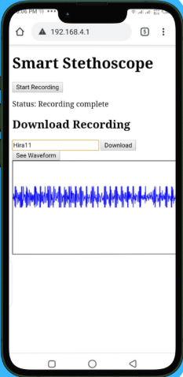
Figure 4.1: ESP32’s Asynchronous Server Webpage

4.2.4 File Management and Storage Integrity
To manage storage limitations of SPIFFS:
- After a recording is downloaded, the corresponding file is automatically deleted after a 10-second delay, ensuring that flash memory space is recycled.
- The deletion operation is scheduled and executed without interrupting ongoing system tasks.
This approach maintains file system health by preventing the accumulation of obsolete data while guaranteeing the availability of at least one recording for user download.

4.2.5 System Timing and Performance Monitoring
Throughout the recording process:
- Timestamps (micros()) are utilized to measure the true duration of recording.
- Based on the number of samples collected and total recording time, the actual achieved sampling rate is computed and displayed via serial output. This feature assists in performance verification and debugging.

4.3 Power Supply and Battery Management
A reliable and efficient power supply system is essential for maintaining continuous functionality in a portable biomedical device like a smart stethoscope and to meet this requirement the system uses a rechargeable lithium-ion battery which provides mobility extended usage duration and operational safety. The power design utilizes a 3.7V 2000mAh 18650 Li-Ion battery as the main power source along with a TP4056 lithium-ion charging module that handles charging and battery protection while an MT3608 DC-DC boost converter is integrated to regulate the output voltage to levels required by the electronic components in the system. All these components are carefully chosen to meet performance safety and compactness standards that align with the wearable and portable nature of the device.

4.3.1 Lithium-Ion Battery (3.7V 2000mAh 18650 Cell)
The 18650 lithium-ion battery serves as the primary energy storage unit for the device and is capable of delivering adequate power for extended periods of operation without requiring frequent recharging as it offers a nominal voltage of 3.7V and a capacity of 2000mAh. Its compact form factor combined with a lightweight structure and high energy density makes it particularly suitable for integration into wearable biomedical devices where portability and long-lasting performance are essential.

4.3.2 TP4056 Lithium-Ion Charging Module
The TP4056 charging module is integrated into the system to ensure safe and efficient recharging of the lithium-ion battery by utilizing a linear charging mechanism based on the constant-current/constant-voltage (CC/CV) algorithm, which is specifically suited for lithium-based battery chemistries. This module accepts a 5V input from a standard USB interface, making it convenient for recharging using commonly available adapters or power banks. A typical TP4056 module includes the TP4056 integrated circuit, along with battery protection circuitry that features the DW01 protection IC and FS8205 dual MOSFET, which work together to provide overcharge, over-discharge, overcurrent, and short-circuit protection, essential for ensuring both the longevity of the battery and the safety of the user, especially in portable applications. Furthermore, the module includes onboard LEDs that offer visual feedback, with a red LED indicating active charging and a blue LED signaling that the battery is fully charged.

4.3.3 MT3608 DC-DC Boost Converter
Most of the electronic components used in the system such as the ESP32 microcontroller and the MAX9814 microphone module require a regulated 5V power supply to operate optimally, and since the nominal voltage of the 18650 battery is only 3.7V, a DC-DC boost converter is employed to step up the voltage. The MT3608 module is chosen for this purpose due to its high efficiency, compact size, and adjustable output voltage, and in this design, the module is configured to output 5V to meet the power requirements of the components.

4.4 Enclosure Design and 3D-Printed Chamber
A well-designed enclosure is crucial for protecting the internal electronic components of a biomedical device, ensuring ergonomic usage, and maintaining the system's overall aesthetics. For the smart stethoscope, a custom 3D-printed enclosure was created to house the microphone, microcontroller, power supply modules, and associated circuitry in a compact, user-friendly form factor. This enclosure not only provides mechanical support but also contributes significantly to heat dissipation and enhances user interaction.

4.4.1 Design Considerations
The enclosure was designed using SolidWorks CAD software with the goal of optimizing space, protecting internal components, ensuring acoustic sensitivity, and improving ergonomics. To promote passive airflow and prevent heat buildup, a hole was placed near the power circuitry and microcontroller region. The top panel features openings for a power switch, a micro-USB charging port aligned with the TP4056 module, and stethoscope piping.
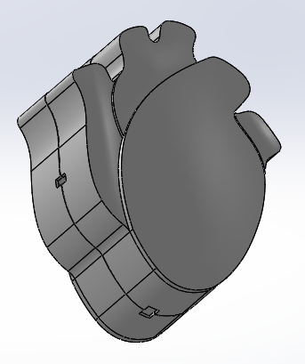 | 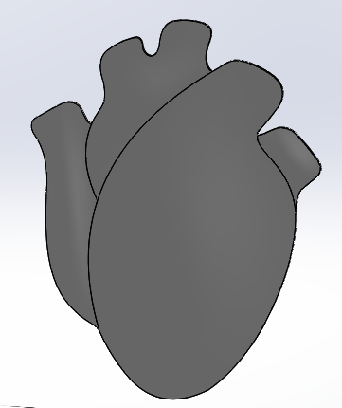 | 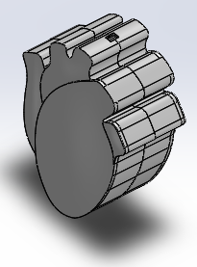
Perspective View | Front View | Isometric View
Figure 4.2: 3-D model designed for device’s casing in Solidworks
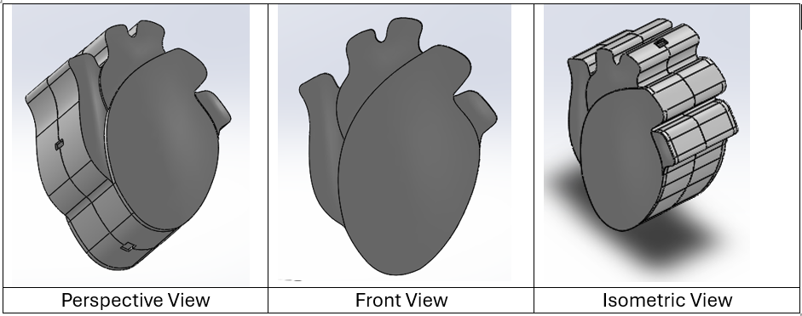
The enclosure is ergonomically designed for handheld use with smooth curves and rounded edges to enhance user comfort. Its size is optimized to ensure a comfortable grip and ease of handling.
- Compact allowing it to be clipped or held comfortably during auscultation
- Lightweight ensuring it does not fatigue the user during extended use
- Non-obstructive maintaining access to the chest wall during diagnosis

4.5 Complete Hardware Setup
The physical hardware setup is comprised of:
Component | Details
Microcontroller | DOIT ESP32 DEVKIT V1
Microphone | MAX9814 module
Microphone Power Supply | 3.3V (provided by ESP32)
Microphone Output | Connected to ESP32 ADC Pin (GPIO35)
Flash Storage | Internal SPIFFS (ESP32 flash memory)
Connectivity | Wi-Fi AP mode (direct smartphone/laptop connection)
Power Supply | 3.7V 2000mAh Lithium ion cell, tp4056 battery charging module
Device enclosure | 3-D printed casing
Table 4.1: Complete hardware setup
The designed system is self-contained, portable and does not rely on any external internet services. Recording, visualization, and data download are all achievable through a web browser and mobile application making it an ideal solution for real-time and offline stethoscope signal acquisition.
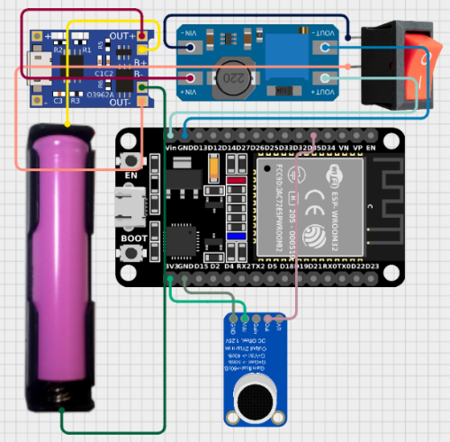  Figure 4.3: Circuit Diagram | 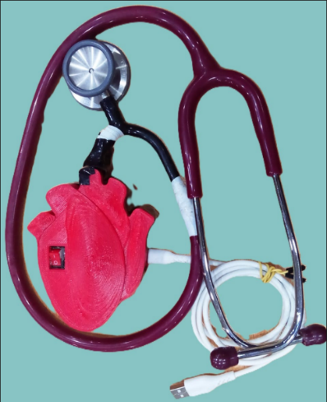  Figure 4.4: Harware Device prototype

4.6 Summary
The smart stethoscope's hardware architecture is designed with a strong emphasis on portability, low power consumption and signal fidelity. Each component is carefully selected to guarantee robustness and facilitate seamless integration with software modules for intelligent signal analysis. The system bridges traditional auscultation with AI-driven diagnostics, enhancing early detection of cardiovascular and pulmonary abnormalities.

Chapter 5: Denoising of Heart Sounds

5.1 Introduction
Heart sound signals also referred to as phonocardiograms or PCGs are non-stationary low-frequency bioacoustic signals that are naturally prone to various types of noise and interference during acquisition which may include ambient noise respiratory sounds motion artifacts and internal electronic noise generated by the acquisition system. Accurate denoising of PCG signals is essential to enable effective analysis such as feature extraction and classification. In this chapter a two-stage denoising pipeline is presented where the first stage utilizes bandpass filtering through a 7th order Butterworth filter to retain the frequency components most relevant to heart sounds while the second stage employs Variational Mode Decomposition or VMD to extract the most informative mode that represents the clean signal. This combined approach is designed to eliminate unwanted noise while preserving the diagnostically important features of the heart sounds.

5.2 Butterworth Bandpass Filtering
The Butterworth filter is commonly used in biomedical signal processing because of its maximally flat frequency response in the passband which helps to prevent signal distortion and preserve important signal characteristics. Heart sounds are typically found within the frequency range of around 20 Hz to 500 Hz where the main heart sounds S1 and S2 generally occur and murmurs or pathological components may also appear either within or slightly beyond this range. To effectively isolate these important components a 7th order Butterworth bandpass filter was designed with a low cut-off frequency set at 20 Hz and a high cut-off frequency set at 500 Hz and this filter was applied to the raw PCG signals. The decision to use a filter of order 7 which was made after testing different filter orders helps achieve a steep roll-off that effectively suppresses unwanted frequency components outside the target range while maintaining minimal distortion within the passband.

5.3 Variational Mode Decomposition (VMD)
Following bandpass filtering, the denoised signal is further processed using Variational Mode Decomposition (VMD), a modern signal decomposition technique that separates a signal into a predefined number of band-limited intrinsic mode functions (IMFs) through a variational optimization approach. Unlike Empirical Mode Decomposition (EMD), VMD is robust to noise and mode mixing and provides more stable decomposition results. For the denoising task, VMD was configured to decompose the filtered heart sound into a single mode (k = 1), effectively extracting the most dominant spectral component of the signal, which corresponds to the cleaned heart sound. The balancing parameter α was set to 4000, which controls the trade-off between the smoothness of the decomposed modes and their accuracy in representing sharp transitions or impulses. A higher α value ensures that the extracted mode has a narrow bandwidth and filters out residual high-frequency noise components. The single retained mode after VMD encapsulates the essential dynamics of the heart sound signal, effectively minimizing the impact of remaining noise artifacts.

5.4 Implementation and Results
The denoising pipeline was implemented in Python using standard scientific computing libraries. The bandpass Butterworth filter was realized using the scipy.signal library, while the VMD step was implemented using open-source VMD toolkits. Representative heart sound recordings containing various types of noise were subjected to the two-stage denoising process. Qualitative assessment showed a significant improvement in signal clarity, with enhanced definition of S1 and S2 sounds and better preservation of murmur characteristics where present.
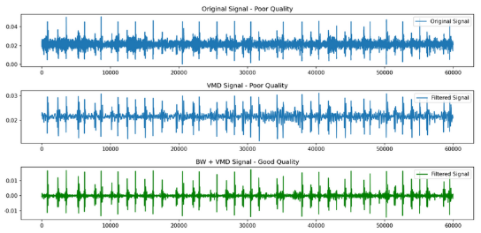
Figure 5.1: Original and denoised PCG signal acguired from smart stethoscope
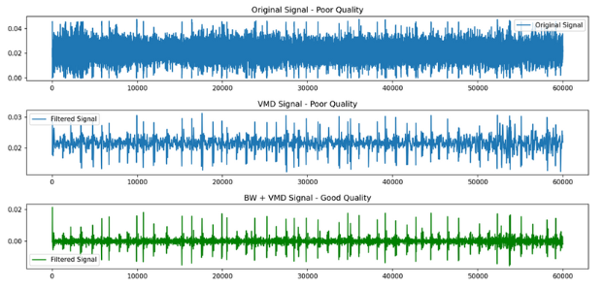
Figure 5.2: Original and denoised PCG signal acguired from smart stethoscope

5.5 Advantages of the Hybrid Approach
Combining bandpass filtering with VMD offers several advantages. The Butterworth filter provides an initial coarse denoising step that reduces the computational burden on VMD by pre-selecting relevant frequency components. The VMD stage, in turn, refines the denoising by isolating the most informative signal structure. This combination effectively mitigates both broadband noise and localized interferences, making it highly suitable for real-time or offline heart sound analysis in noisy environments.

5.6 Summary
This chapter presented a robust heart sound denoising method that integrates traditional digital filtering with advanced decomposition techniques. The 7th order Butterworth bandpass filter from 20 Hz to 500 Hz effectively preserves the frequency components relevant to cardiac auscultation, while Variational Mode Decomposition with parameters k=1 and α=4000 isolates the dominant clean signal component. These methods provide a high-quality, noise-reduced signal that forms a reliable foundation for further processing tasks such as feature extraction and disease classification in the subsequent stages of the smart stethoscope system.

Chapter 6: Quality Assessment of PCG signals

6.1 Introduction
The reliability and clinical relevance of heart sound analysis systems are significantly influenced by the quality of the acquired PCG signals due to which ensuring the integrity of these signals is fundamental to the effectiveness of any automated auscultation or diagnostic system. Phonocardiograms can be severely degraded by ambient noise, handling artifacts, body movements and electronic interference. Poor-quality signals can compromise the accuracy of machine learning models and mislead clinical decisions. To address this challenge a robust pre-screening mechanism is required to evaluate whether a recorded signal is suitable for further diagnostic processing. This chapter outlines an advanced signal quality analysis framework developed to automate the assessment of PCG signal fidelity using frequency-domain analysis and spectral similarity measures.

6.2 Methodology Overview
The approach adopted for signal quality analysis in this system is based on frequency-domain characteristics of heart sounds and involves computing the frequency spectrum of the signal to be assessed and comparing it against a baseline average spectrum derived from known good-quality recordings thereby enabling the system to determine whether a new signal maintains the spectral properties indicative of clean and clinically usable data.

6.3 Spectral Analysis of Heart Sounds
Heart sounds are primarily concentrated in the low-frequency range between 20 Hz and 600 Hz. To evaluate signal quality each time-domain waveform is transformed into the frequency domain using the Fast Fourier Transform which yields a one-sided magnitude spectrum revealing how energy is distributed across frequencies and because noise and distortions introduce irregular components outside the physiological range such as high-frequency spikes from electrical interference or low-frequency drifts from movement artifacts we can infer the presence of such distortions by inspecting the spectral shape. To enable consistent comparison across recordings of varying lengths and sampling rates each spectrum is normalized and resampled to a fixed length so that differences in spectral shape reflect true quality variations rather than differences in duration or sampling rate.

6.4 Reference Spectrum and Similarity Measure
An average spectral profile is generated using a carefully selected set of high-quality heart sound recordings obtained from the publicly available CIRCOR DigiScope Phonocardiogram Dataset. This average profile represents the ideal frequency distribution of a clean heart sound which is then used as a baseline to evaluate the quality of new signals by calculating their frequency spectra and comparing them to this reference and the degree of similarity between the new signal and the reference is determined using a statistical similarity measure based on cosine similarity which assesses how closely the two spectral vectors align in shape regardless of differences in amplitude. A cosine similarity score of 1.0 indicates a perfect spectral match while a score of 0.0 signifies complete dissimilarity and scores closer to 1.0 imply that the signal being evaluated retains the essential spectral properties of clean heart sounds making it suitable for diagnostic use whereas lower similarity scores indicate that the signal may be distorted by noise or missing key heart sound features making it unsuitable for further analysis.

6.5 Threshold-Based Classification
Based on empirical evaluation a similarity threshold is defined to separate good quality signals from poor ones and signals that achieve a similarity score above this predefined threshold are considered acceptable for further diagnostic processing while those that fall below the threshold are flagged as poor quality and may either be discarded or require re-recording and this binary classification mechanism allows the system to provide immediate feedback to the user by indicating whether the acquired signal is suitable or if it needs to be captured again due to insufficient quality.

6.6 Results and Observations
The spectral similarity-based signal quality assessment method was applied to a wide range of heart sound recordings that included both clean samples and recordings contaminated by different types of noise such as ambient interference, motion artifacts and electronic distortion and the method demonstrated high accuracy in distinguishing high quality signals from those that were degraded and recordings that retained the core frequency characteristics of physiological heart sounds closely matched the reference spectral profile while those that were noisy or incomplete showed significant deviation and this approach was found to be reliable consistent and computationally efficient making it suitable for real-time evaluation of signal quality prior to diagnostic analysis.
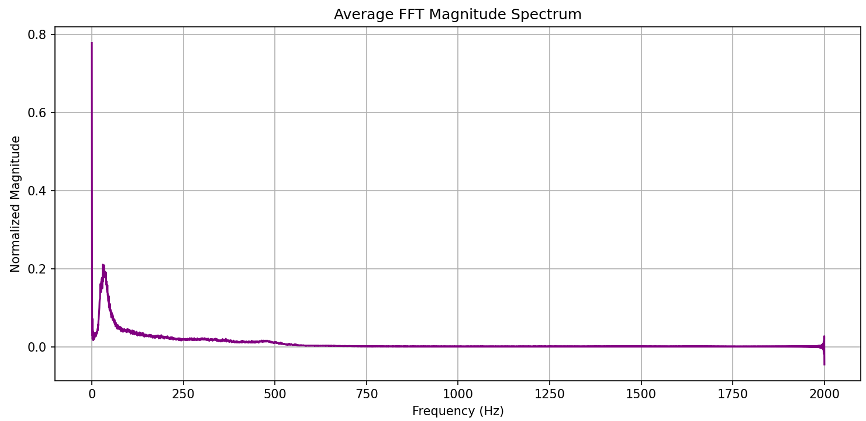
Figure 6.1: Average FFT magnitude spectrum of clean signals obtained from CirCor DigiScope Phonocardigram Dataset
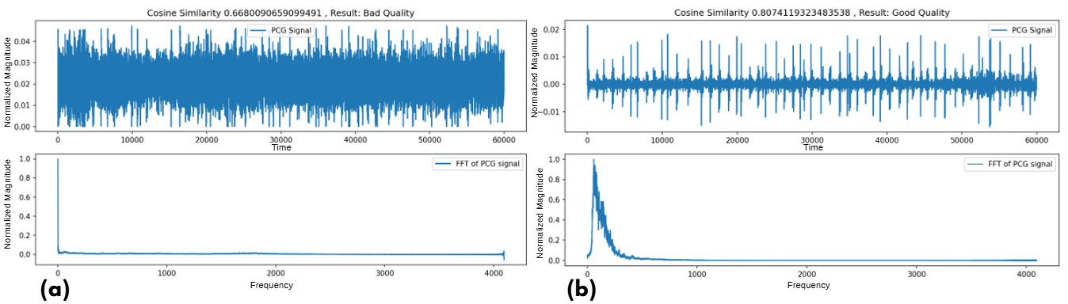
Figure 6.2: Results of quality assessment of recorded PCG signals alonwith their waveforms and FFT (a) Noisy and (b) Clean

6.7 Advantages and Limitations
The described method offers multiple advantages as it is computationally efficient and does not rely on labeled data for every individual signal which makes it well suited for real-time applications on mobile or embedded systems and its dependence on the overall spectral shape rather than the specific content of the recording allows it to be effective across different recording environments and heart sound variations. However the system’s performance is influenced by the quality and diversity of the reference dataset because if the reference set does not adequately represent the range of high-quality signals then the method might incorrectly classify recordings that slightly deviate from the norm due to differences in anatomy or variations in recording conditions and although frequency-domain features provide valuable information they may overlook certain time-domain issues such as clipped waveforms or sudden transient noise that can also impact diagnostic accuracy.

6.8 Conclusion
This chapter presented a spectral similarity-based technique for automated assessment of heart sound recording quality by utilizing frequency-domain analysis to compare the spectral profile of incoming signals with a predefined high-quality reference spectrum, enabling the system to consistently determine whether a recording is appropriate for further diagnostic evaluation and ensuring that only clinically useful data are processed which in turn improves the overall accuracy, dependability and effectiveness of the smart stethoscope system.

Chapter 7: Classification Using Deep Learning

7.1 Introduction
The effectiveness of any AI-powered auscultation system depends on three foundational pillars which are high-quality labeled datasets robust signal preprocessing and accurate classification models. Our Smart Stethoscope system is built upon these components and integrates clinically validated datasets with advanced signal processing and denoising techniques and machine learning models. We utilized two publicly available datasets which are the CIRCOR DigiScope Phonocardiogram Dataset and Yaseen Dataset to capture a wide spectrum of cardiac conditions. To improve the quality of PCG signals a custom denoising pipeline was developed using bandpass filtering wavelet transforms empirical mode decomposition EMD and adaptive filtering.
After denoising we extracted both traditional and advanced features from the PCG signals which serve as inputs to deep learning models. These models form the decision-making core of our diagnostic framework and this chapter outlines the entire pipeline from dataset preparation to signal preprocessing feature extraction and finally the classification model design.

7.2 Dataset Description
7.2.1 Introduction
The performance of any intelligent auscultation system heavily relies on the availability of high-quality labeled datasets. In this project we utilized two datasets the CIRCOR DigiScope Phonocardiogram Dataset and the Yaseen Dataset to support different stages of development for our Smart Stethoscope system.
- Initially, our focus was on binary classification of heart sounds (normal vs abnormal), for which the CIRCOR dataset was well-suited.
- Later, as the project expanded to tackle multi-class classification, the Yaseen dataset was incorporated to address the need for more granular diagnostic capabilities.
7.2.2 CIRCOR DigiScope Dataset
The CIRCOR DigiScope Dataset contains 3,120 PCG recordings labeled as either:
- Normal indicating healthy heart sounds
- Abnormal indicating any pathological cardiac condition.
These recordings were collected in real-world clinical environments from various auscultation sites and contain background noise which made the dataset particularly suitable for developing and validating denoising algorithms. In the initial stages of our project this dataset was used to build and evaluate a binary classification model for differentiate between normal and abnormal heart sounds and its realistic signal conditions also made it valuable for testing the robustness of our signal preprocessing pipeline.
7.2.3. Yaseen Dataset
As the project evolved our goal was to develop a multiclass classification model capable of distinguishing between specific cardiac conditions but the CIRCOR dataset being binary labeled could not support this goal so we adopted the Yaseen Dataset which contains 1000 PCG recordings divided equally into five well-defined classes.
- AS – Aortic Stenosis
- MR – Mitral Regurgitation
- MS – Mitral Stenosis
- MVP – Mitral Valve Prolapse
- Normal – Healthy heart sounds
This dataset provided a clean and well-balanced source of labeled data suitable for training and evaluating multi-class classification models. Each class contained 200 recordings, ensuring class balance and facilitating fair model evaluation.

7.2.4. Unified Use for Binary and Multi-class Classification
- Binary Classification:
For early-stage model development, we used the CIRCOR dataset directly. Later, to validate consistency, we also generated a binary version of the Yaseen dataset by merging all four disease classes (AS, MR, MS, MVP) into a single “Abnormal” class, while retaining the “Normal” class. This helped in cross-validating binary models on a different dataset with less noise.
- Multi-class Classification:
For the final classification system, only the Yaseen dataset was used, given its clear multi-class labels. The models trained on this dataset were capable of distinguishing between different types of valvular heart diseases.
7.2.5. Conclusion
By leveraging both the CIRCOR and Yaseen datasets, our project benefited from a broad spectrum of PCG signal conditions from noisy, real-world recordings to clean, class-balanced datasets. This dual-dataset approach enabled us to develop a flexible Smart Stethoscope system capable of performing both binary and multi-class classification, thus enhancing its practical diagnostic utility.

7.3. Signal Processing and Denoising of Phonocardiogram (PCG) Signals
7.3.1 Introduction
Accurate analysis of heart sounds is very important in the domain of auscultation and has a vital role in the early diagnosis and monitoring of cardiovascular conditions and with the evolution of intelligent medical devices such as the Smart Stethoscope there has been a growing emphasis on developing robust signal processing pipelines that can operate effectively in real-world noisy clinical environments. A primary challenge encountered in automated heart sound diagnostics is the presence of substantial background noise which can severely compromise the accuracy of diagnostic algorithms. This chapter outlines the signal preprocessing and denoising techniques employed to enhance the quality of phonocardiogram PCG signals obtained from the CIRCOR DigiScope dataset and the aim is to suppress noise artifacts while preserving key heart sound features thereby enabling reliable downstream tasks such as feature extraction and classification.
7.3.2 Preprocessing and Denoising Pipeline
To ensure high-quality signal input for further diagnostic analysis a structured signal processing pipeline was developed. This pipeline consists of four primary stages:
- Static bandpass filtering
- Wavelet denoising
- Empirical mode decomposition
- Adaptive filtering using the normalized least mean squares (NLMS) algorithm
- Bandpass Filtering
The first step in the preprocessing pipeline involves attenuating frequency components that fall outside the range of interest for heart sound analysis since heart sounds are predominantly concentrated in the 25 to 400 Hz frequency range and to achieve this a Finite Impulse Response FIR bandpass filter designed using a Hamming window was applied to the raw PCG recordings.
Objective:
- Suppress low-frequency components
- Suppress high-frequency noise
Observation:
- This approach succeeded in reducing out of band noise
- But it was insufficient in isolating heart sounds from complex background interference such as overlapping respiratory sounds or frictional artifacts especially in high-noise recordings.
- Wavelet Denoising
After bandpass filtering wavelet-based denoising was explored to further enhance signal clarity. Discrete Wavelet Transform (DWT) was applied to decompose the signal into different frequency bands allowing selective attenuation of noise while preserving transient heart sound components.
Objective:
- Enhance localization of heart sound events (S1, S2)
- Suppress noise across scales by thresholding wavelet coefficients
Limitation:
- Although wavelet denoising showed improvement in reducing high-frequency noise, it failed to fully eliminate overlapping non-cardiac sounds such as breath and stethoscope friction
- In some cases, over-thresholding led to signal distortion, especially in low-SNR samples
- Therefore, wavelet denoising was not used as a standalone method but rather as a supplementary step
- Empirical Mode Decomposition (EMD)
To further decompose and analyze underlying components Empirical Mode Decomposition (EMD) was employed. EMD breaks down the signal into a finite set of Intrinsic Mode Functions (IMFs) each representing oscillatory modes with varying frequencies.
Objective:
- Isolate noise-dominated IMFs
- Reconstruct the signal using the IMFs most representative of heart sounds
Limitation:
- The selection of IMFs for reconstruction proved challenging
- The boundaries between signal and noise components were often blurred
- Reconstruction led to attenuation or distortion of critical heart sound features such as S1 and S2
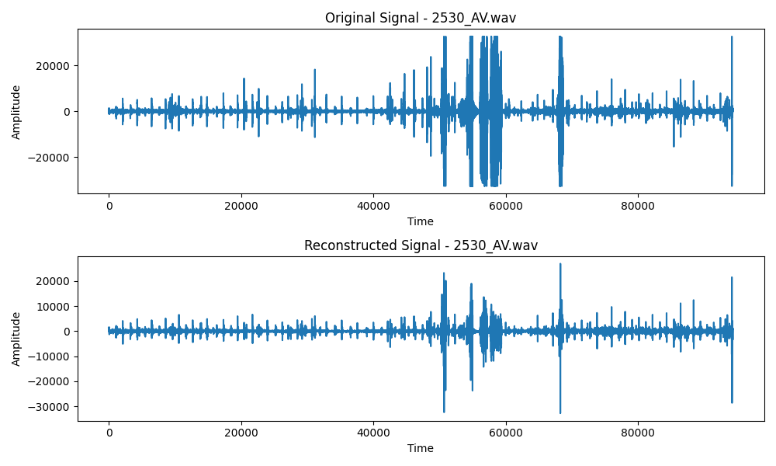
- This limited its overall effectiveness as a standalone denoising technique

Figure 7.1: Original and EMD reconstructed signal plots
- Adaptive Filtering using NLMS
The most effective denoising approach in this study involved adaptive filtering based on the Normalized Least Mean Squares algorithm which dynamically updates filter coefficients to minimize the mean square error between a noisy input signal and a reference and in practice a reference noise signal was either extracted or simulated to guide the adaptation process.
Advantages:
- Adaptability to varying noise conditions
- No fixed assumptions about noise characteristics
- Ability to preserve non-stationary and time-varying signal features
Results:
- NLMS filtering yielded notable improvements in signal clarity
- Common noise artifacts such as breathing sounds and stethoscope friction were significantly attenuated
- The underlying heart sounds emerged with improved definition and reduced distortion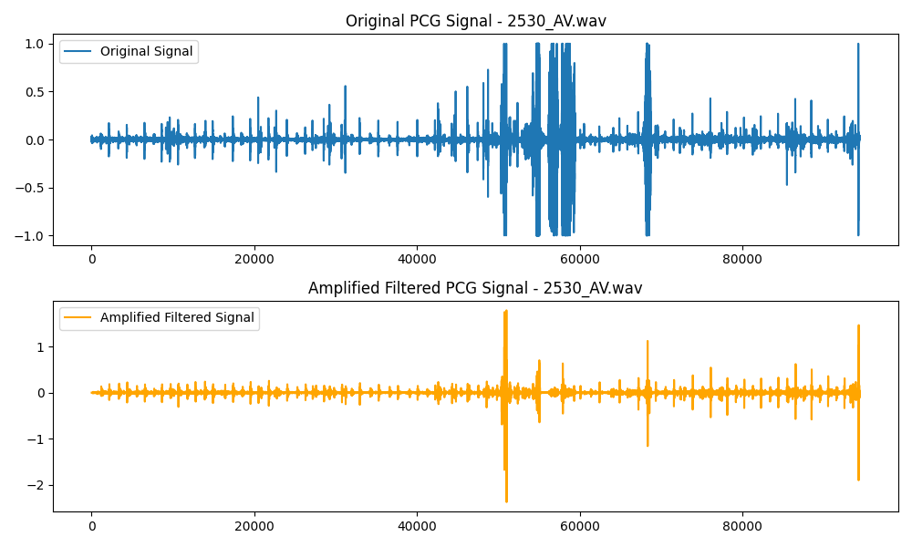
Figure 7.2: Original and NLMS reconstructed signal plots
7.3.3 Conclusion
In this chapter a comprehensive signal processing and denoising strategy for PCG signals was presented focusing on enhancing the input quality for the Smart Stethoscope’s diagnostic algorithms and among the techniques explored adaptive filtering using the NLMS algorithm emerged as the most effective offering substantial improvements in noise suppression and signal clarity and the cleaned PCG signals generated through this pipeline serve as the foundational input for downstream processing stages such as feature extraction and machine learning based classification and given the challenges posed by noisy clinical environments the ability to robustly extract clean heart sounds significantly enhances the practical viability and diagnostic reliability of the Smart Stethoscope system.

7.4 Feature Extraction from PCG Signals

7.4.1 Introduction
Extraction of features is a fundamental step in development of intelligent auscultation systems. It includes transforming raw phonocardiogram (PCG) signals into meaningful numerical descriptors that capture both morphological and temporal patterns of heart sounds. Effective features must be robust to noise, sensitive to pathological variations, and discriminative enough to aid in classification tasks.
In this project, a hybrid feature extraction approach is used, combining both time-frequency and statistical-spectral descriptors. The extracted features serve as the input to machine learning models used for binary and multi-class classification of cardiac conditions.

7.4.2 Extracted Features
The features extracted from each PCG signal are grouped as follows:
  - Mel-Frequency Cepstral Coefficients (MFCCs)
- Capture the short-term power spectrum on a mel-scale, which models human auditory perception.
- Provide a compact and effective representation for timbral textures.
- Computed as:
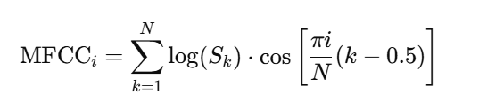
Where S_{k} is the mel-scaled power spectrum and i=1, 2,…,13.
- Delta MFCCs (Δ) and Delta-Delta MFCCs (ΔΔ) capture the first and second derivatives over time, modeling the temporal dynamics of S1, S2, and murmurs.
  - Chroma Features
- Represent energy distribution across 12 pitch classes of the chromatic scale.
- Though initially used in music processing, these features help detect periodic structures in heart sounds.

  - Spectral Features
Feature | Definition | Interpretation
Spectral Centroid | Center of mass of spectral energy | Higher values suggest noisy signals
Spectral Rolloff | Frequency below which 85% of spectral energy is contained | Indicates timbral sharpness
Spectral Flux | Rate of change in the power spectrum across frames | Detects abrupt transitions and murmurs
Spectral Flatness | Ratio of geometric to arithmetic mean of the spectrum | Closer to 1 indicates noise-like signals
Spectral Entropy | Measures randomness or complexity in spectral distribution | Higher values indicate disordered patterns
Spectral Contrast | Difference between peaks and valleys across sub-bands | Captures harmonic vs. non-harmonic regions
Table 7.1: Definitions and interpretations of spectral features extracted from PCG signals
Spectral Entropy Formula:
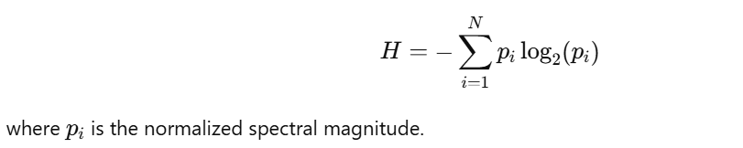

  - Temporal & Statistical Features
Feature | Description
Zero Crossing Rate | Number of sign changes in the signal
RMS Energy | Root Mean Square energy of the signal
Signal Mean/Variance | Basic statistical descriptors
Signal Range | Max - Min value of the signal
Skewness & Kurtosis | Capture shape of amplitude distribution (computed but not used here)
Table 7.2: Description of temporal and statistical features extracted from PCG signals
  - Hjorth Parameters
Useful in biomedical signal analysis:
- Activity: Variance of the signal
- Mobility:
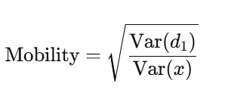
- Complexity:
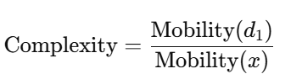
where d₁​ is the first derivative of signal.

  - Shannon Energy Features
- Shannon Entropy: Reflects distribution of energy in the signal.
- Shannon Log Energy: Reflects overall energy level using log transform.
  - Hurst Exponents
Used to estimate long-term memory in the signal:
- Hurst 1: Ratio of second derivative std to original std.
- Hurst 3: Slope of log(variance) vs. log(segment size) curve.
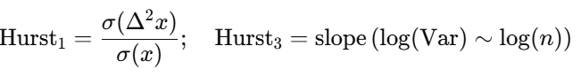
7.4.3 Yaseen Dataset Features:
In addition to the features extracted from the Circor dataset, features from the Yaseen dataset were also extracted for use in classification. The extracted features include:
- The Mel-Frequency Cepstral Coefficients (MFCCs)
- Discrete Wavelet Transform (DWT) Features
- Mel-Frequency Cepstral Coefficients (MFCCs)
- Capture the short-term power spectrum on a mel-scale, which models human auditory perception.
- Provide a compact and effective representation for timbral textures.
- Computed as:

Where S_{k} is the mel-scaled power spectrum and i=1, 2,…,13.
- Discrete Wavelet Transform (DWT) Features
In addition to MFCCs Discrete Wavelet Transform features were extracted from the Yaseen dataset to capture both high frequency and low frequency components of the signal and the DWT allows for the multi resolution analysis of the signal which is particularly useful for identifying transient events such as heart murmurs and abnormal heart sounds and the DWT decomposition provides both approximation and detail coefficients which are then analyzed for their statistical properties to enhance classification performance.

7.4.4 Implementation Note
All features were extracted using Python libraries including Librosa, NumPy, and SciPy. To ensure consistency:
- Signals were sampled at a fixed rate and padded/truncated to a uniform length.
- Missing or erroneous spectral calculations were handled with exception handling.
- Final feature vectors were standardized (zero mean, unit variance) before being passed to machine learning models.

7.4.5 Conclusion
The combination of MFCCs perceptual chroma spectral statistics Hjorth parameters entropy based features and novel indicators like the Hurst exponent forms a comprehensive and multiscale representation of PCG signals and the inclusion of MFCC and DWT features extracted from the Yaseen dataset further enhances the discriminative power of the feature set and this hybrid feature set effectively captures temporal transitions between heart phases spectral complexity and energy distribution and biomedical indicators of signal variability and structure and this thorough feature extraction pipeline significantly contributes to the accuracy generalizability and interpretability of the Smart Stethoscope classification system.

7.5 Deep Learning Models for PCG Signal Classification

7.5.1 Introduction
This chapter outlines the evolution of our deep learning pipeline designed for the classification of phonocardiogram (PCG) signals. The goal was to develop an accurate, efficient, and mobile-compatible system for real-time auscultation. Multiple models were developed and refined through iterative experimentation, beginning with simple CNN and MLP architectures and culminating in an optimized, lightweight mobile deployment framework. The classification tasks include both binary (normal vs. abnormal) and multi-class cardiac condition recognition.

7.5.2 Model-1: 2D CNN on Spectrograms of Denoised PCG Signals
Objective:
Binary classification (Normal vs. Abnormal)
Pipeline:
- Dataset: CirCor Heart Sound Dataset
- Preprocessing:
  - The raw PCG signals were first denoised using Normalized Least Mean Squares (NLMS) adaptive filtering to suppress environmental and body motion artifacts.
  - Spectrograms were then computed from these denoised signals using short-time Fourier transform (STFT) to generate two-dimensional time-frequency representations suitable for image-based deep learning.
- Model Architecture (2D CNN):
  - Input: 2D Spectrogram image
  - Layers:
    - Conv2D → 32 filters, kernel size 3x3, ReLU activation
    - BatchNormalization
    - Dropout (0.25)
    - Conv2D → 64 filters, kernel size 3x3, ReLU
    - BatchNormalization
    - Dropout (0.25)
    - Flatten
    - Dense → 128 units, ReLU
    - Dropout (0.5)
    - Dense → 1-unit, Sigmoid activation

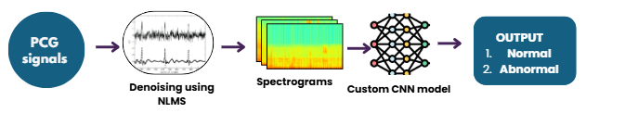
Figure 7.3: Spectrogram based custom CNN binary model architecture
Results:
- Accuracy: 59%
- Insight: While the CNN effectively captured time-frequency characteristics, the model exhibited limited generalization, likely due to the relatively shallow architecture and inherent variability in PCG signals. The use of spectrograms alone may have overlooked some salient temporal features.
- Confusion Matrix:
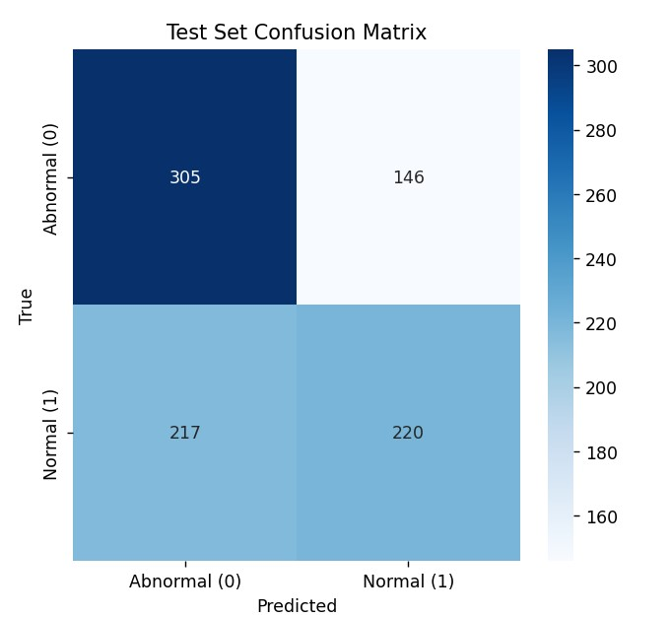
Figure 7.4: Confusion matrix of spectrogram based custom CNN binary model

7.5.3 Model-2: MLP on Extracted Features from Denoised Signals
Objective:
Binary classification
Pipeline:
- Dataset: CirCor
- Preprocessing:
  - NLMS denoising
  - Handcrafted features extracted: MFCCs, entropy, Hjorth parameters, Hurst exponent, etc.
- Model Architecture (MLP):
  - Input: 1D feature vector
  - Layers:
    - Dense → 128 units, ReLU
    - BatchNormalization
    - Dropout (0.3)
    - Dense → 64 units, ReLU
    - Dropout (0.3)
    - Dense → 1-unit, Sigmoid activation
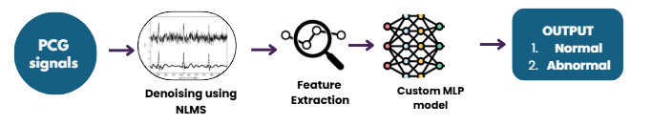
Figure 7.5: Features based custom MLP binary model architecture

Results:
- Accuracy: 57%
- Insight: The model's underperformance highlighted the limitations of shallow MLPs in capturing complex patterns in feature space, especially when working with nonlinear and noisy biomedical signals. However, the extracted features proved useful in later ensemble modeling.
- Confusion Matrix:
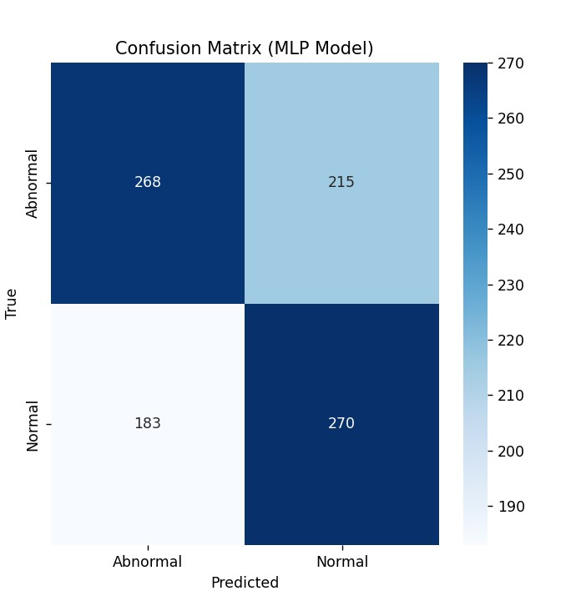
Figure 7.6: Confusion matrix of features based custom MLP binary model

7.5.4 Model-3: Ensemble of CNN and MLP with Gradient Boosting
Objective:
Binary classification using ensemble learning
Pipeline:
- Predictions from Model-1 and Model-2 were concatenated into a new feature vector.
- This vector was used as input to a Gradient Boosting Classifier (XGBoost ) for final prediction.
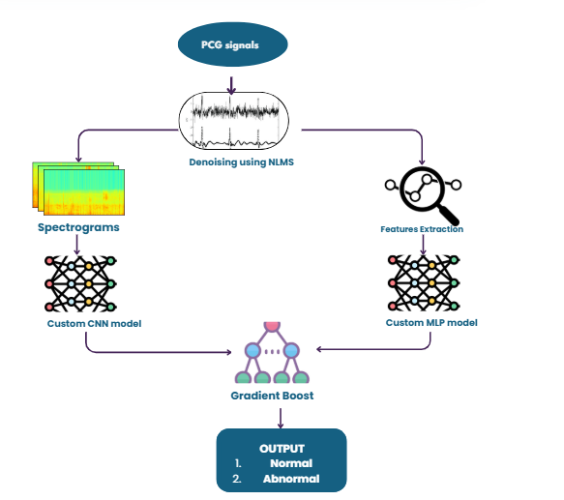
Figure 7.7: Architecture of Gradient Boosting–Ensembled Binary Classification Model
Results:
- Accuracy: 87%
- Insight: This demonstrated that CNNs and MLPs captured complementary decision boundaries, and ensemble boosting significantly improved overall performance.
- Confusion Matrix:
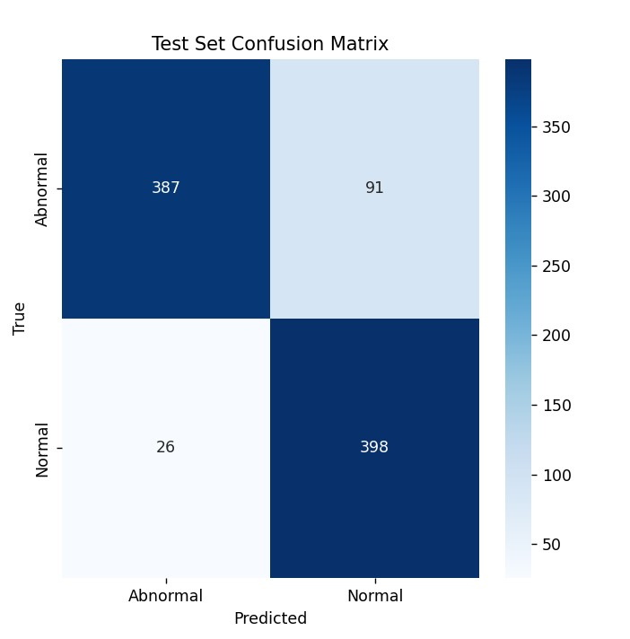
Figure 7.8: Confusion matrix of Gradient Boosting–Ensembled Binary Classification Model

7.5.5 Model-4: Lightweight CNN + Gradient Boosting (Mobile Friendly)
Objective:
Reduce model size for offline mobile deployment
Pipeline:
- Removed the MLP model from the ensemble.
- Retained only CNN predictions from Model-1.
- Applied Gradient Boosting on CNN outputs.
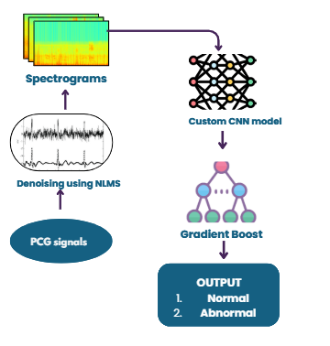
Figure 7.9: Spectrogram based custom CNN model architecture

Results:
- Accuracy: 80%
- Trade-off: Acceptable accuracy with reduced computational cost suitable for mobile apps.
- Confusion Matrix:
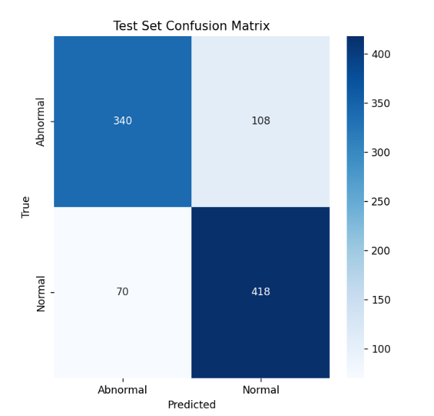
Figure 7.10: Confusion matrix of spectrogram based custom CNN model architecture

7.5.6 Model-5: Fully Convolutional Two-Stage CNN
Objective:
Replace gradient boosting with neural nets for end-to-end mobile efficiency
Pipeline:
- Step 1: PCG → NLMS → Spectrograms → First CNN
- Step 2: First CNN prediction vector → Second CNN → Final classification
Details of Architecture:
- Both CNNs used 2D convolution layers, structured as:
  - Conv2D → 32 filters, 3x3, ReLU
  - BatchNormalization
  - Dropout (0.25)
  - Conv2D → 64 filters, 3x3, ReLU
  - BatchNormalization
  - Flatten → Dense → Final output
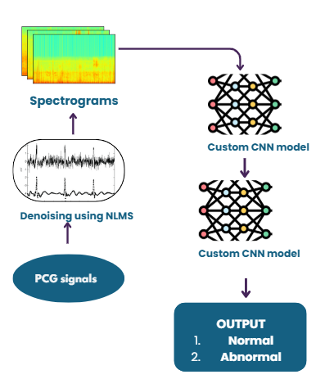
Figure 7.11: Dual-stage spectrogram-based CNN architecture
Results:
- Accuracy: 81%
- Strength: Fully CNN-based pipeline removed dependency on gradient boosting and supported efficient mobile inference.
- Confusion Matrix:
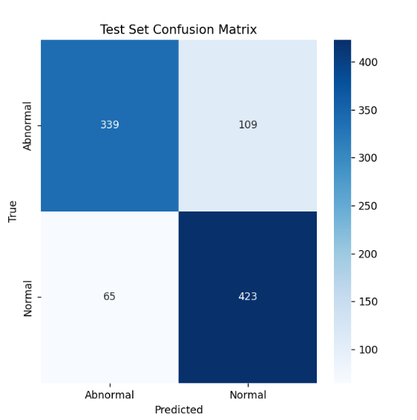
Figure 7.12: Confusion matrix of Dual-stage spectrogram-based CNN

7.5.7 Model-6: Multi-Class 1D CNN on MFCC + Wavelet Features (Yaseen Dataset)
Objective:
Multi-class classification (Normal, Murmur, Extrasystole, Artifact, etc.)
Pipeline:
- Dataset: Yaseen Dataset (multi-class annotated PCG recordings)
- Preprocessing:
  - NLMS denoising
  - Feature extraction: MFCC + Wavelet coefficients → 1D feature vectors
- Model Architecture (1D CNN):
  - Input: 1D feature vector
  - Layers:
    - Conv1D → 64 filters, kernel size 3, ReLU
    - BatchNormalization
    - Dropout (0.3)
    - Conv1D → 128 filters, kernel size 3, ReLU
    - BatchNormalization
    - Flatten
    - Dense → 128 units, ReLU
    - Dropout (0.5)
    - Dense → Output classes, Softmax activation
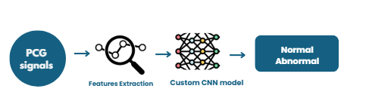
Figure 7.13: Feature based custom CNN binary model architecture

Results:
- Accuracy: 98%
- Highlight: Excellent feature design and model depth enabled accurate multi-class discrimination.
- Confusion Matrix:
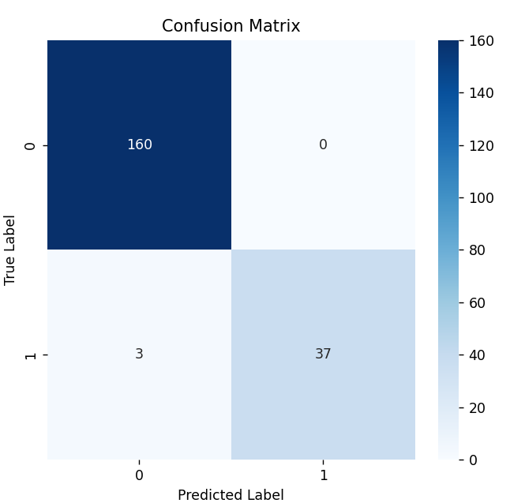

Figure 7.14: Confusion matrix of feature based custom CNN binary model

7.5.8 Model-7: Multi-Class 1D CNN on Structured Features
Objective:
Multi-class classification using structured features from Yaseen dataset
Pipeline:
- Similar to Model-6 but tailored for a slightly reduced feature set.
- Fed directly into a custom 1D CNN.
Architecture:
- Similar Conv1D architecture with more filters or depth.
- Dropout, BatchNormalization, and Dense layers for classification.
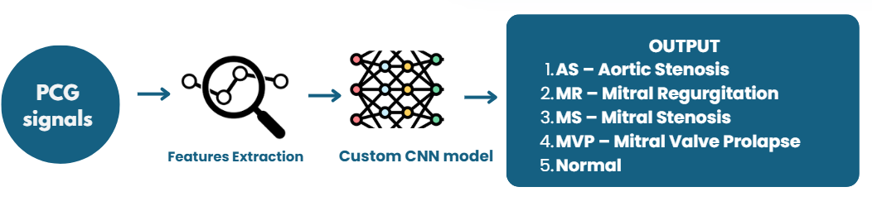
Figure 7.15: Feature based custom CNN multi-class model architecture

Results:
- Accuracy: 95%
- Use case: Lighter alternative to Model-6 with slightly lower accuracy but faster inference.
- Confusion Matrix:
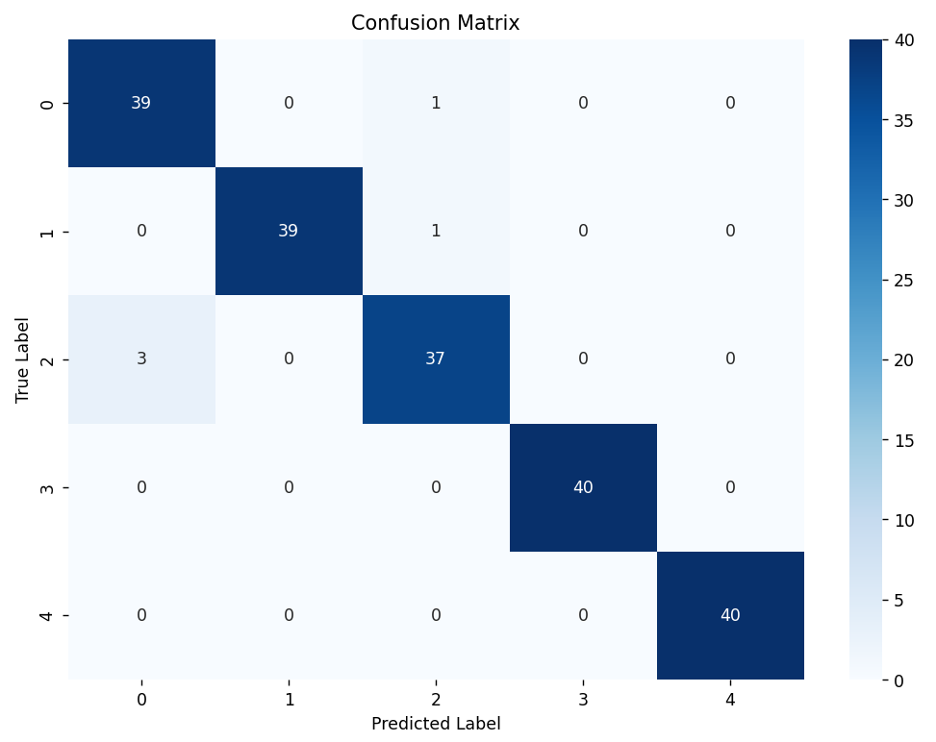
Figure 7.16: Confusion matrix of feature based custom CNN multi-class model

7.5.9 Summary Table
Model | Pipeline Summary | Conv Type | Classifier | Task | Accuracy
Model-1 | Denoised → Spectrograms → CNN | 2D Conv | Custom CNN | Binary | 59%
Model-2 | Denoised → Features → MLP | — | Custom MLP | Binary | 57%
Model-3 | CNN + MLP predictions → Gradient Boosting | — | Ensemble (GB) | Binary | 87%
Model-4 | CNN → Gradient Boosting (No MLP, for mobile use) | 2D Conv | Lightweight Ensemble | Binary | 80%
Model-5 | CNN1 → CNN2 (Fully Convolutional Pipeline for mobile) | 2D Conv | Custom CNN → CNN | Binary | 81%
Model-6 | MFCC + Wavelet Features → 1D CNN (Multiclass Yaseen dataset) | 1D Conv | Custom CNN | Multi-class | 98%
Model-7 | Features → 1D CNN (Multiclass classifier on structured input) | 1D Conv | Custom CNN | Multi-class | 95%
Table 7.3: Summary of Classification models

7.5.10 Conclusion
This evolving pipeline—from raw PCG preprocessing to ensemble learning and finally to 1D and 2D CNNs—demonstrates the effectiveness of methodical experimentation. While early models struggled with generalization, thoughtful feature engineering, model architecture tuning, and ensemble strategies led to significant improvements. Importantly, deployment on mobile devices was a driving factor in architectural simplification, ultimately leading to a robust and portable diagnostic solution.

Chapter 8: Transfer Learning

8.1 Introduction
Deep learning has made a significant impact on biomedical signal analysis over the years. It has improved the automated diagnosis systems drastically. But it may be hard to train deep neural networks from scratch. The majority of the time it comes at the expense of large amounts of labeled data and powering computing equipment. These are usually limited within specialized medical disciplines such as analysis of phonocardiogram (PCG).
Transfer learning has become an effective remedy which can be used to resolve this. In a previously trained general neural network that learns from a large data set the specific task is modified. What is to be done now is the classification of heart sounds. The idea is to recycle what the model already knows not to have to start anew. This is especially beneficial when there is insufficient data in that the model can learn efficiently even with fewer data.
In using the approaches of transfer learning to problems of medical signal classification such as the analysis of PCG the future is particularly hopeful. Heart sounds are quite complex and subtle meaning sometimes there is the need for expert interpretation. When transforming these signals that are one-dimensional time series into a two dimensional spectrogram we can leverage high performance Convolutional Neural Networks (CNNs) that were developed for image recognition. Such models trained to identify complex patterns and features from millions of images, can already be reused to perform PCG classifying based on spectrograms.

8.2 Methodology
In this work we investigate the use of three well known deep learning networks AlexNet, MobileNet, and GoogleNet, as the foundation for transfer learning in our smart stethoscope system. Each of the models has its own strong points:
- GoogleNet introduces Inception modules which can use multiscale feature extraction and deliver higher accuracy using fewer parameters.
- MobileNet is a good fit for mobile and embedded devices and is applicable for our smart stethoscope used in the edge computing devices.
- AlexNet, because of its simplicity and background in deep learning research, remains a great baseline even though it was one of the first deep CNNs.
After incorporating these models into our pipeline we would assess how well they perform in categorising cardiac sounds and eventually enhance our device's diagnostic capabilities in resource constrained real world scenarios.

8.3 Dataset Description
For this study, we employed the CIRCor Dataset an open access phonocardiogram (PCG). The CIRCor Dataset contains over 3,000 PCG recordings collected from multiple auscultation locations namely the aortic, pulmonic, tricuspid, and mitral areas using digital stethoscopes. These recordings were sourced from patients of various age groups and clinical backgrounds in clinical environments across multiple countries, contributing to the diversity and realism of the dataset. Each audio sample is accompanied by metadata including patient age, sex, recording location, and clinical diagnosis.

8.3.1 Signal Characteristics
PCG signals of the dataset are one-dimensional audio recording, sampled at 4000 Hz. The recorded files contain both clean and noisy samples in order to act as a true representation of the real-world conditions in which the stethoscope recordings are captured. Each recording is accompanied with a list of significant clinical data that include the acceptability or otherwise of the heart sound and presence or absence of a murmur.

8.3.2 Class Distribution and Labeling Approach
The original CIRCor Dataset gives multi label diagnostic information enabling classification according to several categories, including “normal”, “murmur present”, “murmur suspected” and certain types of congenital or acquired cardiac disorders. However, because of the complexity and clinical overlap of numerous diagnostic labels and the limited number of samples for some uncommon categories, we decided to reduce the complication of the problem into a binary classification problem. This binary based approach was informed by two major considerations.
- Practical deployment:
In real life screening situations for instance in remote or poorly resourced areas the most crucial first step one can take is to ascertain that a patient’s heart sound is either in the normal range or in keeping with a possible pathology. This bi facility facilitates referral based decision making.
- Label robustness:
Although refined classification is a desirable feature the variety of subcategories in the dataset has little or noisy data. Classifying all pathologies under the “abnormal” class reduces the label ambiguity and increases the reliability of training the model.

8.3.3 Data Challenges
Despite these challenges the CIRCor Dataset was selected because its clinical richness diversity and real world relevance make it ideal for auscultation applications and its structure aligns closely with the objectives of our Smart Stethoscope project which seeks to deliver an AI powered diagnostic tool capable of performing preliminary cardiac assessments in settings where expert clinicians are not available.

8.4 Technical Pipeline
An overview of the complete technical pipeline used to develop the classification model with transfer learning on the CIRCor Dataset is presented in this section and encompasses preprocessing heart sound recordings converting them into spectrograms organizing the data into meaningful classes and training deep learning architectures under two experimental conditions.

8.4.1 Preprocessing
The CIRCor PCG recordings vary greatly in length and include real world noise from movement breathing artifacts and inconsistent recording conditions so to achieve uniformity and improve the quality of spectrogram generation we applied a series of preprocessing steps that standardize signal duration suppress noise and prepare the data for reliable time frequency analysis.
8.4.1.1 Standardizing Signal Lengths
PCG recordings in the dataset vary in duration from a few seconds to over a minute and this inconsistency poses a challenge for deep learning models that require fixed input dimensions. To address this we computed the average duration of all recordings by using librosa to load each file and calculate its length in seconds and then we resampled every recording to match a fixed number of audio samples so that recordings longer than the average were truncated and recordings shorter were upsampled by recalculating the sample rate proportionally and padded as needed and the resulting signals were saved in a new folder to ensure uniform duration and sampling rate and this normalization reduced variability due to temporal differences and ensured consistency during spectrogram generation.
8.4.1.2 File Management and Length Recording
A log of signal lengths (minimum, maximum, average) was saved in a text file to maintain transparency and reproducibility. Additionally all standardized audio signals were stored in a dedicated folder ready for further processing.

8.4.2 Spectrogram Generation and Class Organization
Heart sounds are non-stationary signals making time-frequency representations such as spectrograms ideal for analysis. After length standardization we converted the signals into spectrograms as follows:
8.4.2.1 Spectrogram Creation
Each PCG waveform was transformed into a mel-spectrogram or short-time Fourier transform (STFT)-based spectrogram using librosa.
These spectrograms capture important acoustic features including frequency patterns of systolic and diastolic murmurs in a 2D image format compatible with pre-trained CNN architectures.
8.4.2.2 Label Mapping and Folder Structuring
A metadata CSV file (updated_file.csv) provided outcome labels (Normal or Abnormal) for each patient.
Using a custom script, each spectrogram image was matched to its corresponding patient outcome and moved to either the normal or abnormal class folder.
This organized dataset (under a root Data_Classes directory) facilitated easy loading for model training and evaluation.

8.4.3 Experimental Design: Two Approaches
To evaluate the effect of adaptive filtering on classification performance we designed two distinct experimental pipelines.
8.4.3.1 Approach 1: Unfiltered Signals
In this approach the standardized raw PCG signals were directly converted into spectrograms without applying any noise reduction or signal enhancement filters. This simulates a minimal preprocessing scenario to assess how well pre-trained CNNs can generalize from unfiltered real-world data.
8.4.3.2 Approach 2: Filtered Signals
Here we implemented adaptive filtering techniques on the PCG signals before generating spectrograms. Adaptive filters are ideal for dynamic environments like heart recordings because they adjust based on noise characteristics. The filtering helped suppress non-cardiac artifacts such as respiratory noise or stethoscope friction improving the clarity of the resulting spectrograms. After filtering the signals were processed identically to the unfiltered approach. This comparative setup allowed us to investigate whether additional signal processing benefits transfer learning based classification tasks.

8.5. Transfer Learning with Deep Learning Architectures
We employed three state of the art convolutional neural network (CNN) architectures GoogleNet (Inception-v3), MobileNet, and AlexNet using a transfer learning strategy to classify spectrograms.
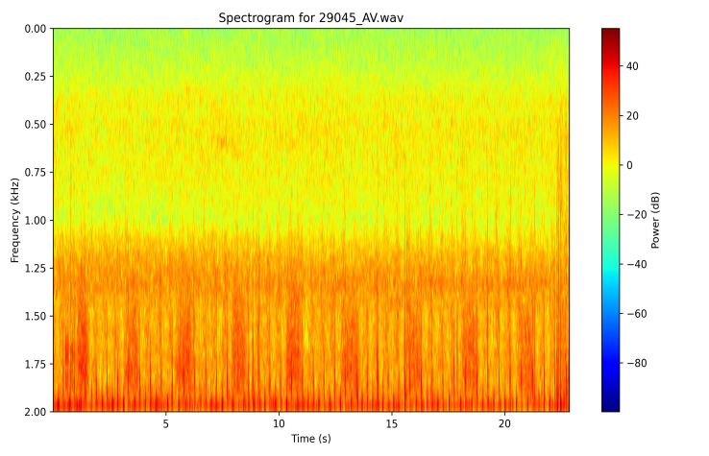
Figure 8.1: Spectrogram of a PCG signal from CirCor DigiScope Phonocardiogram Dataset

8.5.1 Why Transfer Learning?
Transfer learning leverages models pre-trained on large-scale datasets (e.g., ImageNet) and adapts them to domain specific tasks with limited labeled data. Given the relatively modest size of labeled medical datasets this approach enhances performance and reduces the need for extensive computational resources and training time.

8.5.2 Model Implementation
- GoogleNet (Inception-v3): Known for its inception modules and multi-scale feature extraction making it effective for capturing hierarchical patterns in spectrograms.
- MobileNet: A lightweight architecture optimized for mobile deployment. It uses depthwise separable convolutions to reduce computation while retaining accuracy.
- AlexNet: A foundational CNN with five convolutional layers and three fully connected layers. Though older it provides a useful baseline for comparison.
Each model was fine tuned using transfer learning. The final classification layers were replaced with a binary classifier. Models were trained separately on filtered and unfiltered spectrograms. Performance was evaluated using training and testing accuracy metrics to observe potential overfitting and generalization capabilities.

8.6 Experimental Results and Analysis
To explore automated classification of heart signals, transfer learning was initially applied using three widely adopted deep convolutional neural networks, GoogleNet, AlexNet, and MobileNet. These models were repurposed using spectrogram representations of phonocardiogram (PCG) signals with the objective of performing binary classification between normal and abnormal heart sounds.
Two datasets were prepared: one based on filtered signals, where noise reduction techniques such as adaptive filtering were applied and another consisting of unfiltered raw signals preserving the original acoustic information. The intention was to evaluate the generalization capabilities of each pre-trained model under both conditions.

8.6.1 Transfer Learning with Unfiltered PCG Signals
In the first approach we trained our transfer learning models on spectrograms generated from raw PCG signals without any filtering or denoising. This represents a real world scenario where background noise and recording artifacts are present.
Model | Training Accuracy | Testing Accuracy
GoogleNet | 46.41% | 98.35%
AlexNet | 43.23% | 69.70%
MobileNet | 39.34% | 96.05%
Table 8.1: Result of transfer learning using GoogleNet, AlexNet and MobileNet on original signals from CirCor DigiScope Phonocardiogram Dataset
AlexNet Confusion Matrix:

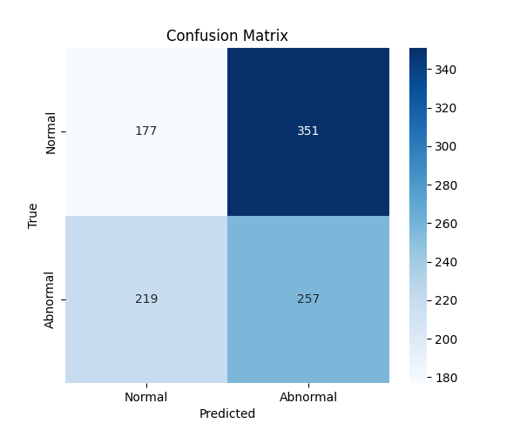
Figure 8.2: Confusion Matrix of transfer learning using AlexNet on signals from CirCor DigiScope Phonocardiogram dataset
MobileNet:

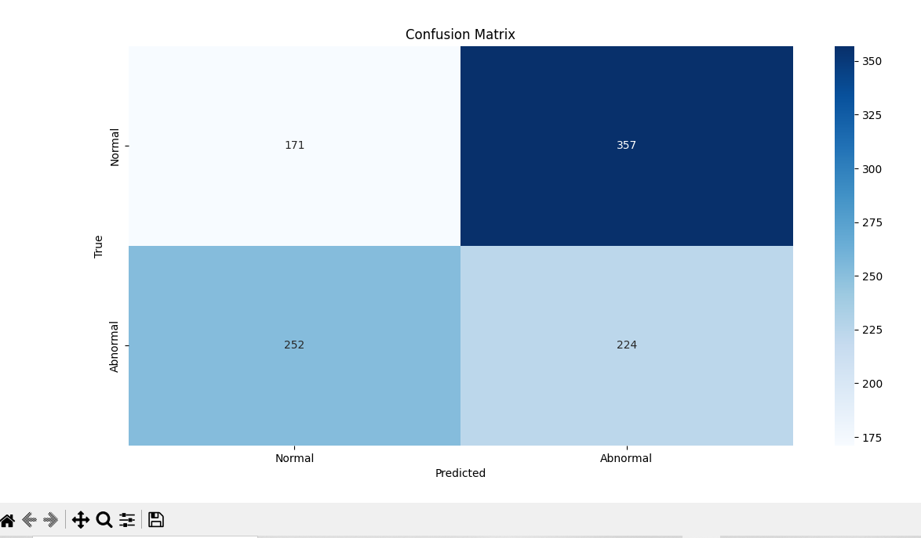
Figure 8.3: Confusion Matrix of transfer learning using MobileNet on signals from CirCor DigiScope Phonocardiogram dataset

GoogleNet:
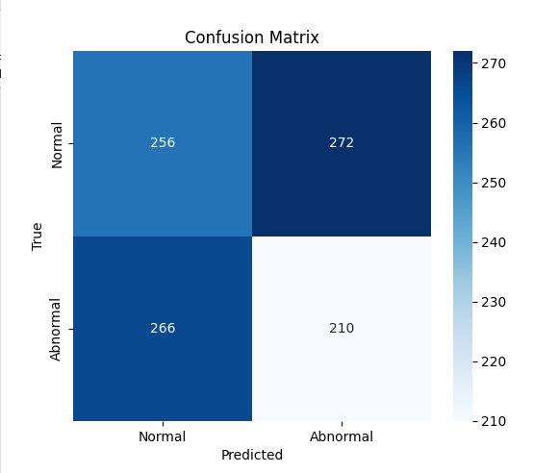
Figure 8.4: Confusion Matrix of transfer learning using GoogleNet on signals from CirCor DigiScope Phonocardiogram dataset
8.6.1.1 Interpretation:
When working with unfiltered signals, GoogleNet and MobileNet achieved very high training accuracy suggesting a strong capacity to memorize patterns. Yet again the testing accuracy failed to surpass 50%, indicating a lack of real-world generalization. The performance gap between training and testing was even more pronounced than in the filtered dataset, particularly for GoogleNet, which reached 98.35% training accuracy but only 46.41% testing accuracy. This suggests that while unfiltered data contained richer raw features, the models were unable to extract and generalize these features effectively without task-specific adaptation.

8.6.2 Transfer Learning with Filtered PCG Signal
In this approach, adaptive filtering was applied to each PCG signal prior to spectrogram generation to suppress noise and enhance cardiac sound clarity. The filtered spectrograms were then used to train the models.
Model | Testing Accuracy | Training Accuracy
GoogleNet | 47.39% | 93.80%
AlexNet | 46.13% | 69.65%
MobileNet | 41.64% | 89.90%
Table 8.2: Result of transfer learning using GoogleNet, AlexNet and MobileNet on pre-processed signals from CirCor DigiScope Phonocardiogram Dataset
AlexNet:
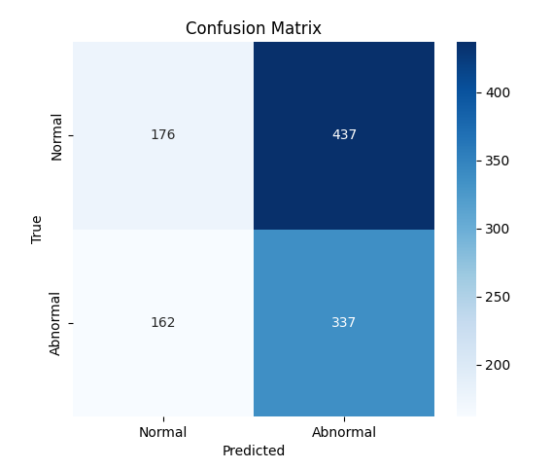
Figure 8.5: Confusion Matrix of transfer learning using AlexNet on pre-processed signals from CirCor DigiScope Phonocardiogram dataset
MobileNet:

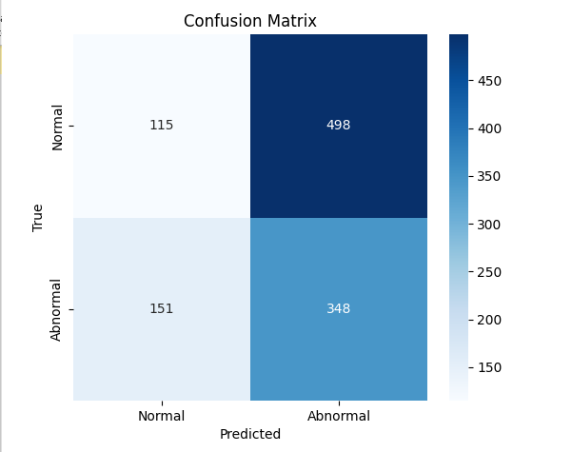
Figure 8.6: Confusion Matrix of transfer learning using MobileNet on pre-processed signals from CirCor DigiScope Phonocardiogram dataset

GOOGLE NET:

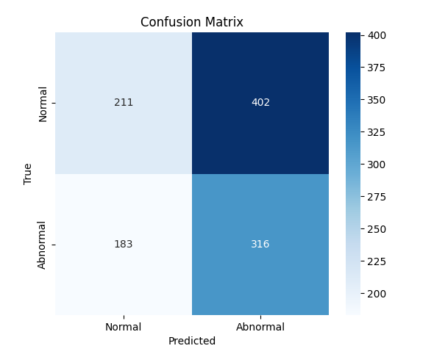
Figure 8.7: Confusion Matrix of transfer learning using GoogleNet on pre-processed signals from CirCor DigiScope Phonocardiogram dataset
8.6.2.1 Interpretation:
All three models achieved high training accuracy, with GoogleNet and MobileNet performing best, which shows that the networks successfully learned patterns from the training data. Yet their testing accuracy stayed below fifty percent for every model exposing a serious overfitting problem and indicating that the features learned during training did not translate to unseen data. Although applying filtering removed background noise and improved signal clarity it also appears to have diminished the variety of signal characteristics needed for robust classification, resulting in disappointing performance on the test set.

8.6.3. Evaluation and Comparative Justification
The results from both filtered and unfiltered datasets highlight a core limitation of applying generic transfer learning models to PCG classification because these networks although highly effective for natural image recognition unable to capture and generalize the complex spectro-temporal dynamics of heart sound signals.
Key issues observed:
- Overfitting manifested as a stark discrepancy between training and testing accuracies which shows that the models became excessively tuned to the training examples and therefore lack any robustness when presented with new unseen samples.
- Domain mismatch occurred because models pretrained on natural image datasets operate on data whose structure and content differ fundamentally from medical spectrograms and this difference prevents the networks from learning the relevant spectro-temporal features of heart sounds.
- Insufficient generalization was evident as none of the models managed to exceed fifty percent accuracy on test data under any experimental condition, underscoring their consistent failure to learn the discriminative features required for reliable heart sound classification.
In contrast a separate line of experimentation involving a custom-designed CNN showed significantly improved testing performance and better generalization particularly in binary classification. This model was tailored to the characteristics of PCG spectrograms, with optimized depth, kernel sizes, and regularization strategies to suit the data. Given the shortcomings of transfer learning, the superior performance of the custom CNN provided strong justification for its adoption as the preferred architecture in subsequent stages of the project.

8.6.4 Summary of Findings
Dataset Type | Model | Training Accuracy | Testing Accuracy | Observation
Filtered Signals | GoogleNet | 93.80% | 47.39% | High training; poor generalization
Filtered Signals | AlexNet | 69.65% | 46.13% | Moderate performance; under 50% testing
Filtered Signals | MobileNet | 89.90% | 41.64% | Overfit; testing accuracy below threshold
Unfiltered Signals | GoogleNet | 98.35% | 46.41% | Strong overfitting; low real-world accuracy
Unfiltered Signals | AlexNet | 69.70% | 43.23% | Weak generalization
Unfiltered Signals | MobileNet | 96.05% | 39.34% | Worst testing performance
Table 8.3: Summary of results and observations from transfer learning on CirCor DigiScope Phonocardiogram dataset

8.7 Conclusion:
While transfer learning offered a rapid initial framework for experimentation the models were not well-suited to the nuanced classification of PCG signals. Their inability to generalize effectively led to the informed decision to adopt a custom CNN architecture better aligned with the domain-specific needs of heart sound diagnosis.

Chapter 9: Smart Stethoscope Mobile Application

9.1 How to Use the Smart Stethoscope
This section outlines the step by step procedure for operating the Smart Stethoscope mobile application designed to interface with a custom built ESP32 based device for recording and analyzing heart sounds.
Step 1: Power On the Device
Turn on the Smart Stethoscope hardware. Upon powering up device will activate its built-in Wi-Fi module (ESP32) creating a wireless access point for direct connection.
Step 2: Connect to Device Wi-Fi
Using your smartphone navigate to the Wi-Fi settings and connect to the Smart Stethoscope’s Wi-Fi network. This enables a direct link between the mobile app and the device for data transfer.
Step 3: Enter Patient ID
Launch the application and enter a unique Patient ID. This step ensures that each recording is tagged correctly for future reference and diagnosis.
Step 4: Prepare for Recording
Gently place the stethoscope’s chest piece on the patient’s chest, preferably at a standard auscultation site over the heart. Recordings should be taken in a quiet environment to minimize background noise.
Step 5: Record the Heart Sound
Tap on the "Start Recording" button within the app to begin capturing the heart sound. Each recording lasts for 15 seconds. During this period it is important to keep the device stable for optimal audio quality.
Step 6: Save and Playback
After recording, use the “Save Recording” option to store the PCG data locally as a .wav file. You may also choose to play back the audio or view the waveform for immediate inspection.
Step 7: Use a Previous Recording
To analyze an existing file, tap “Select File and Diagnose” browse to the desired .wav recording stored on your device and proceed with diagnosis.
Step 8: Run Diagnosis
The application performs a two stage classification:
- Stage 1: Binary classification determines whether the heart sound is Normal or Abnormal.
- Stage 2: If Abnormal, a detailed diagnosis is provided from the following five categories:
- Aortic Stenosis
- Mitral Stenosis
- Mitral Regurgitation
- Mitral Valve Prolapse
- Normal
Step 9: View Saved Recordings
All saved PCG files can be accessed from the “Saved Recordings” tab. Users can review, replay, or use these recordings for further diagnosis as needed.

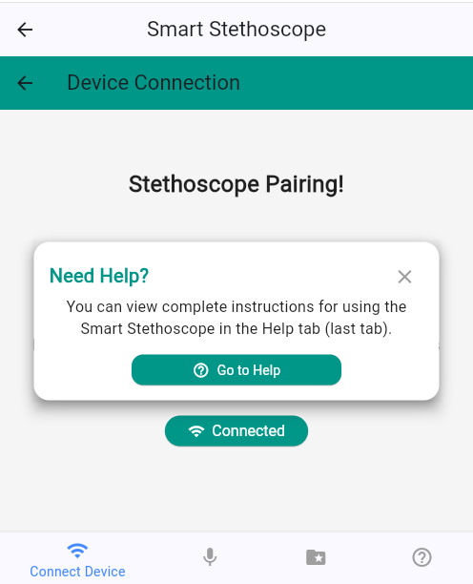
Figure 9.1: Navigation to Help upon starting Smart Stethoscope Mobile App
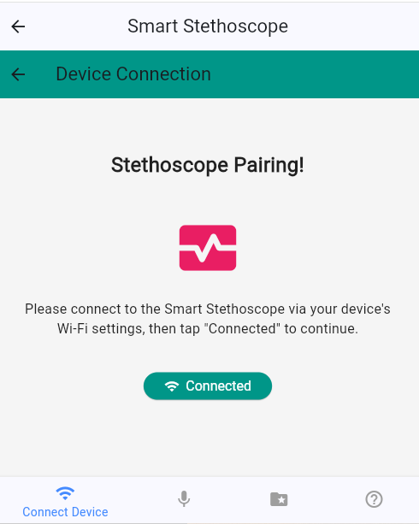
Figure 9.2: Connect Device page of Smart Stethoscope Mobile App

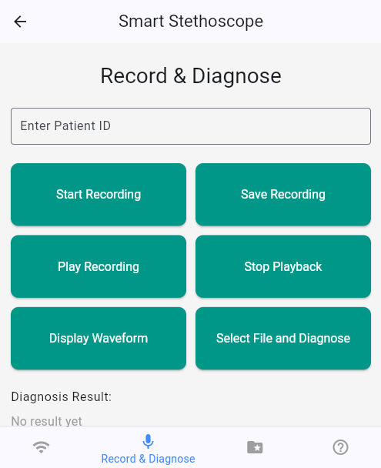
Figure 9.3: Connect Device page of Smart Stethoscope Mobile App

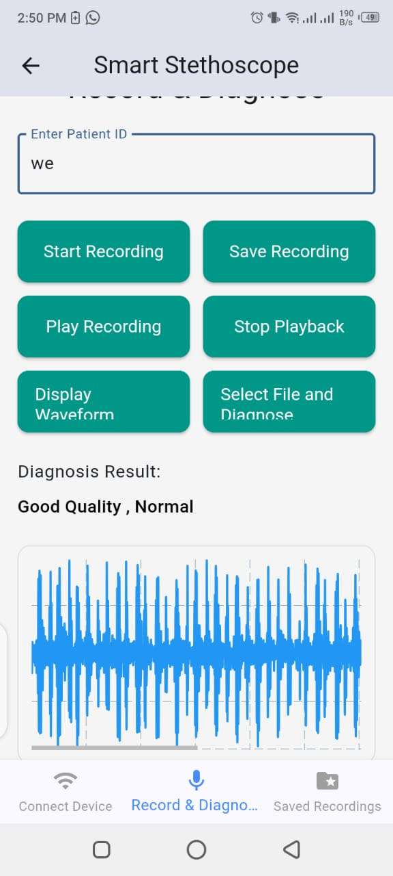
Figure 9.4: Diagnosis result and waveform of a real-time PCG signal recording on Smart Stethoscope Mobile App

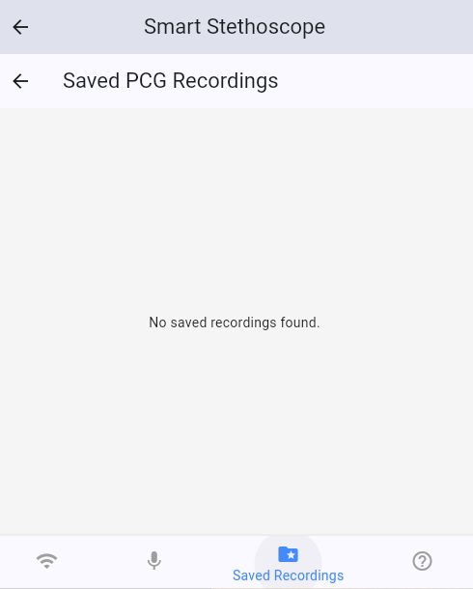
Figure 9.5: Saved recordings page of Smart Stethoscope Mobile App

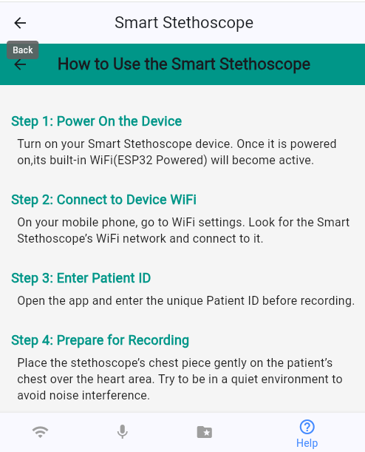
Figure 9.6: Help page of Smart Stethoscope Mobile App

9.2 Conclusion
The smart stethoscope mobile app offers a user-friendly interface for using smart stethoscope device and provides functionality for real-time pcg signal recording or using already recorded pcg signals, denoising, quality assessment and classification.

Chapter 10: Conclusion and Future Work

10.1 Conclusion
This thesis presents the complete design and implementation of a smart stethoscope system that aims to improve early detection and diagnosis of cardiovascular conditions by combining biomedical sensing embedded systems signal processing and artificial intelligence into a single portable tool. The system uses a high-sensitivity microphone based on the MAX9814 to capture phonocardiogram signals which are then digitized and wirelessly transmitted using an ESP32 microcontroller to a mobile device where all further processing is done locally without requiring internet access. Once the signal is received on the mobile device it undergoes denoising followed by spectrogram generation and then deep learning-based classification using a convolutional neural network and a meta-CNN that work together to accurately detect abnormal heart sounds and potential valvular diseases. The hardware design includes a custom 3D-printed ABS enclosure to ensure portability and durability along with a battery-powered power system that incorporates safe charging and voltage regulation circuits to support continuous and reliable operation. The final working prototype shows strong potential for use in remote rural and primary care environments where there is limited access to advanced diagnostic equipment and trained cardiologists making it a valuable tool for delivering real-time automated cardiac assessment and supporting the broader goal of accessible AI-driven healthcare.

10.2 Future Work
While the current system meets the core objectives of heart sound acquisition, classification, and offline deployment, several areas offer potential for future enhancement:
- The addition of respiratory sound analysis could further increase the utility of the system by allowing simultaneous diagnosis of pulmonary conditions such as wheezing, crackles, or asthma.
- Cloud synchronization and telemedicine integration may be included in future iterations to enable secure long-term storage teleconsultation and integration with electronic health records extending the current offline system into a connected healthcare ecosystem
- Clinical validation and dataset expansion should be pursued through large-scale trials with diverse patient populations to ensure real-world applicability while a larger balanced dataset will improve model generalization and reduce bias
- User interface improvements can transform the mobile application by adding intuitive dashboards multilingual support audio playback physician annotations and feedback loops for continuous learning
By addressing these areas the smart stethoscope can evolve from a diagnostic aid into a comprehensive clinical support tool especially relevant for preventive cardiology and community-based healthcare delivery.

References
[1] Lo, Frank & Meng, Max. (2016). A low cost Bluetooth powered wearable digital stethoscope for cardiac murmur. 1179-1182. 10.1109/ICInfA.2016.7831998.
[2] Wang, H., Fang, Y., Gao, Z., Wang, Y., & You, H. (2017). A heart sound acquisition and analysis system based on PSoC4. International Journal of Engineering Innovation and Management, 7(2), 22.
[3] Talukdar, C., & Chutia, R. (2018). Design and Development of a Microcontroller Based Electronic Stethoscope.
[4] Hadiyoso, Sugondo & Mardiyah, Dieny & Nur Ramadan, Dadan & Ibrahim, Asril. (2020). Implementation of electronic stethoscope for online remote monitoring with mobile application. Bulletin of Electrical Engineering and Informatics. 9. 10.11591/eei.v9i4.2231.
[5] S. S. Joshi, M. R. Patil, N. P. Kanawade and A. P. More, "Bluetooth-based Wireless Digital Stethoscope," 2021 International Conference on Emerging Smart Computing and Informatics (ESCI), Pune, India, 2021, pp. 197-202, doi: 10.1109/ESCI50559.2021.9396835.
[6] Y. -C. Wu and F. -L. Chang, "Development of an Electronic Stethoscope Using Raspberry," 2021 IEEE International Conference on Consumer Electronics-Taiwan (ICCE-TW), Penghu, Taiwan, 2021, pp. 1-2, doi: 10.1109/ICCE-TW52618.2021.9603045.
[7] wu, yu-chi & Han, Chin-Chuan & Chang, Chao-Shu & Chang, Fu-Lin & Chen, Shi-Feng & Shieh, Tsu-Yi & Chen, Hsian-Min & Lin, Jin-Yuan. (2022). Development of an Electronic Stethoscope and a Classification Algorithm for Cardiopulmonary Sounds. Sensors. 22. 4263. 10.3390/s22114263.
[8] Li, Xiao & Shang, Yujing & Wei, Jiaqi & Zhou, Yiheng. (2023). Research on electronic stethoscope system and signal processing algorithm. Journal of Physics: Conference Series. 2634. 012037. 10.1088/1742-6596/2634/1/012037.
[9] Potdar, Ravindra. (2024). Design and Implementation of an Integrated Electronic Stethoscope System. International Journal of Research Publication and Reviews. 5. 5874-5880. 10.55248/gengpi.5.0624.1614
[10] Fahim, Mahabur & Chowdhury, Md & Ghosh, Avishek & Hossan, Arif. (2024). Development of a Low-Cost Wireless Phonocardiograph Using Bluetooth Module with a User Friendly Smartphone Application. 853-857. 10.1109/ICEEICT62016.2024.10534563.
Yaseen, M., Son, G.-Y., & Kwon, S. (2018). Classification of heart sound signal using multiple features. Applied Sciences, 8(12), 2344. https://doi.org/10.3390/app8122344
[11] T. H. Chowdhury, K. N. Poudel, and Y. Hu, “Time-frequency analysis, denoising, compression, segmentation, and classification of pcg signals,” IEEE Access, vol. 8, pp. 160882–160890, 2020.
[12] O. Deperlioglu, “Classification of segmented phonocardiograms by convolutional neural networks,” BRAIN - Broad Research in Artificial Intelligence and Neuroscience, vol. 10, no. 2, pp. 5–13, 2019.
[13] O. DEPERL˙IG˘ LU, “Classification of segmented heart sounds with artificial neural networks,” International Journal of Applied Mathematics Electronics and Computers, vol. 6, no. 4, pp. 39–44, 2018.
[14] H. Alaskar, N. Alzhrani, A. Hussain, and F. Almarshed, “The implementation of pretrained AlexNet on PCG classification,” in Proc. ICIC, (San Sebastian, Basque Country), pp. 784–794, 2019.
[15] N. M. Khan, M. S. Khan, and G. M. Khan, “Automated heart sound classification from unsegmented phonocardiogram signals using time frequency features,” International Journal of Computer and Information Engineering, vol. 12, no. 8, pp. 598–603, 2018.
[16] A. Yadav, M. K. Dutta, C. M. Travieso, and J. B. Alonso, “Automatic classification of normal and abnormal PCG recording heart sound recording using Fourier transform,” in Proc. IWOBI, (Alajuela Province, Costa Rica), pp. 1–9, 2018.
[17] Q. Hu, J. Hu, X. Yu, and Y. Liu, “Automatic heart sound classification using one dimension deep neural network,” in Proc. SpaCCS, (Nanjing, China), pp. 200–208, 2020.
[18] S. K. Ghosh, R. K. Tripathy, R. Ponnalagu, and R. B. Pachori,“Automated detection of heart valve disorders from the PCG signal using time-frequency magnitude and phase features,” IEEE Sensors Letters, vol. 3, no. 12, pp. 1–4, 2019.
[19] A. Bourouhou et al., “Heart sound signals segmentation and multiclass classification,” International Journal of Online and Biomedical Engineering, vol. 16, no. 15, pp. 64–79, 2020.
[20] B. Ahmad et al., “Automatic classification of heart sounds using long short-term memory,” in Proc. ICOSST, (Virtual), pp. 1–6, 2021.
[21] S. A. Singh et al., “Short PCG classification based on deep learning,” in Deep Learning Techniques for Biomedical and Health Informatics, pp. 141–164, Elsevier, 2020.
[22] F. Noman et al., “A markov-switching model approach to heart sound segmentation and classification,” IEEE Journal of Biomedical and Health Informatics, vol. 24, no. 3, pp. 705–716, 2019.
[23] F. Noman et al., “Short-segment heart sound classification using an ensemble of deep convolutional neural networks,” in Proc. ICASSP, (Brighton, UK), pp. 1318–1322, 2019.
[24] J. Dastagir, F. A. Khan, M. S. Khan, and K. N. Khan, “Computer-aidedphonocardiogram classification using multidomain time and frequency features,” in Proc. ICAI, (Islamabad, Pakistan), pp. 50–55, 2021.
[25] A. Meintjes, A. Lowe, and M. Legget, “Fundamental heart sound classification using the continuous wavelet transform and convolutional neural networks,” in Proc. EMBC, (Honolulu, Hawaii), pp. 409–412, 2018.
[26] Z. Abduh, E. A. Nehary, M. A. Wahed, and Y. M. Kadah, “Classification of heart sounds using fractional fourier transform based melfrequency spectral coefficients and traditional classifiers,” Biomedical Signal Processing and Control, vol. 57, no. 101788, pp. 1–11, 2020.
[27] S. A. Singh, S. Majumder, and M. Mishra, “Classification of short unsegmented heart sound based on deep learning,” in Proc. I2MTC, (Auckland, New Zealand), pp. 1–6, 2019.
[28] S. Li, F. Li, S. Tang, and F. Luo, “Heart sounds classification based on feature fusion using lightweight neural networks,” IEEE Transactions on Instrumentation and Measurement, vol. 70, pp. 1–9, 2021.
[29] N. Ibrahim et al., “A comparative study of heart sound signal classification based on temporal, spectral and geometric features,” in Proc. IECBES, (Langkawi, Malaysia), pp. 24–29, 2020.
[30] W. Zeng, J. Yuan, C. Yuan, Q. Wang, F. Liu, and Y. Wang, “A new approach for the detection of abnormal heart sound signals using TQWT, VMD and neural networks,” Artificial Intelligence Review, vol. 54, no. 3, pp. 1613–1647, 2021.
[31] M. V. Shervegar and G. V. Bhat, “Heart sound classification using gaussian mixture model,” Porto Biomedical Journal, vol. 3, no. 1, pp. 1–7, 2018.
[32] J. M.-T.Wu et al., “Applying an ensemble convolutional neural network with Savitzky–Golay filter to construct a phonocardiogram prediction model,” Applied Soft Computing, vol. 78, pp. 29–40, 2019.
[33] P. T. Krishnan et al., “Automated heart sound classification system from unsegmented phonocardiogram (pcg) using deep neural network,”Physical and Engineering Sciences in Medicine, vol. 43, no. 2, pp. 505–515, 2020.
[34] B. Al-Naami, H. Fraihat, N. Y. Gharaibeh, and A.-R. M. Al-Hinnawi,“A framework classification of heart sound signals in physionet challenge 2016 using high order statistics and adaptive neuro-fuzzy inference system,” IEEE Access, vol. 8, pp. 224852–224859, 2020.
[35] A. I. Humayun et al., “An ensemble of transfer, semi-supervised and supervised learning methods for pathological heart sound classification,” in Proc. INTERSPEECH, (Hyderabad, India), pp. 127–131, 2018.
[36] S. Boll, “Suppression of acoustic noise in speech using spectral subtraction,”IEEE Transactions on acoustics, speech, and signal processing, vol. 27, no. 2, pp. 113–120, 1979.
[37] P. Langley and A. Murray, “Heart sound classification from unsegmented phonocardiograms,” Physiological measurement, vol. 38, no. 8, pp. 1658–1670, 2017.
[38] V. N. Varghees and K. Ramachandran, “Effective heart sound segmentation and murmur classification using empirical wavelet transform and instantaneous phase for electronic stethoscope,” IEEE Sensors Journal, vol. 17, no. 12, pp. 3861–3872, 2017.
[39] Yaseen, Son, G.-Y., & Kwon, S. (2018). Classification of Heart Sound Signal Using Multiple Features. Applied Sciences, 8(12), 2344. https://doi.org/10.3390/app8122344
[40] Tang, Hong, Dai, Ziyin, Jiang, Yuanlin, Li, Ting, Liu, Chengyu, PCG Classification Using Multidomain Features and SVM Classifier, BioMed Research International, 2018, 4205027, 14 pages, 2018. https://doi.org/10.1155/2018/4205027
[41] Yang, Lijun & Li, Shuang & Zhang, Zhi & Yang, Xiaohui. (2019). Classification of Phonocardiogram Signals Based on Envelope Optimization Model and Support Vector Machine. Journal of Mechanics in Medicine and Biology. 20. 10.1142/S0219519419500623.
[42] Chakraborty, Devjyoti & Bhattacharya, Snehangshu & Thakur, Ayush & Gosthipaty, Aritra & Datta, Chira. (2020). Feature Extraction and Classification of Phonocardiograms using Convolutional Neural Networks. 275-279. 10.1109/ICCE50343.2020.9290565.
[43] Ali Mohammad Alqudah (2019) Towards classifying non-segmented heart sound records using instantaneous frequency based features, Journal of Medical Engineering & Technology, 43:7, 418-430, DOI: 10.1080/03091902.2019.1688408.
[44] Abbas, Q.; Hussain, A.; Baig, A.R. Automatic Detection and Classification of Cardiovascular Disorders using Phonocardiogram and Convolutional Vision Transformers. Diagnostics 2022, 12,3109. https://doi.org/10.3390/diagnostics12123109

